Power
in
Of Mice and Men
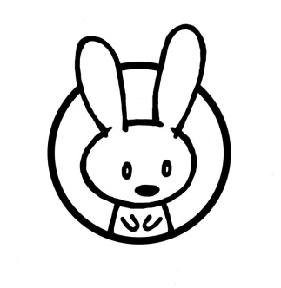

Preparation for Controlled Assessment
Power

There are many themes in Of Mice and Men. One of the most prominent of these is that of power. This theme is present from the very first section all the way through to the last.

Using the diagram below, list all of the ways you can see power being displayed in the novel. Remember to consider the historical context of the novel. The first one has been done for you:

George has power over Lennie because he can control everything that Lennie thinks and does.

Power in Of Mice and Men

Hints and Tips

Here are a few things to consider if you are having trouble identifying power in the novel:
- The position of women in 1930s USA
- The position of black people in 1930s USA
- Curley as the son of the ranch’s owner
- Slim being described as “the prince of the ranch”
- Sexuality used as power
- Physical strength and stature
- Lennie’s ability to emotionally blackmail George
- The desire to have a better life
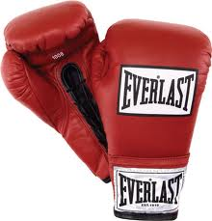
Types of Power

Power in Of Mice and Men can be broken down into three main branches:

- Physical power
- Power of seduction
- Power of hierarchy

From the diagram you have made above, sort the answers you have given into the most relevant column, depending on what kind of power you believe the answers represent.

Physical Power | Power of Seduction | Power of Hierarchy

Each of these three types of power is important, and all should be addressed and interpreted in detail to achieve an A/A* grade answer.
C/B answers may address all elements of power but lack any depth of interpretation.
D/C answers will refer to one or two of these elements, but lack any interpretation.
Physical Power

Two main characters in the novel represent physical power: Lennie and Curley. Lennie is a “huge man” of little intelligence. Curley is “a thin young man” who has “done quite a bit in the [boxing] ring.”

Using the table below, identify the physical characteristics of the two characters that suggest their power.

Lennie | Curley

From the first time the characters meet, it is clear to the reader that there will be conflict between them. Consider the following quotation from Candy:

“Curley’s like a lot of little guys. He hates big guys. He’s alla time picking scraps with big guys. Kind of like he’s mad at em’ because he ain’t a big guy.”

It could be said that Curley overestimates his own power. He picks a fight with Lennie after the other ranch hands mock him.

Why do you think Curley picks on Lennie?

__________________________________________________________________________________

__________________________________________________________________________________

__________________________________________________________________________________

__________________________________________________________________________________

Even though Curley is “balanced and poised” in his fighting style, as soon as Lennie begins to fight back Curley is overpowered. When Lennie grabs his fist, Curley is reduced to “flopping like a fish on a line.” Any physical power and skill that he has is no match for Lennie’s brute strength.

Why do you think Steinbeck includes the fight scene between Lennie and Curley? When Lennie breaks Curley’s fighting hand, what do you think this symbolises?

__________________________________________________________________________________

__________________________________________________________________________________

__________________________________________________________________________________

__________________________________________________________________________________

__________________________________________________________________________________

__________________________________________________________________________________

__________________________________________________________________________________

__________________________________________________________________________________

__________________________________________________________________________________

__________________________________________________________________________________

__________________________________________________________________________________

__________________________________________________________________________________

Lennie’s physical power is a danger not only because it is so strong, but because he cannot control his own strength.

List all of the events in the novel that are caused by Lennie not being able to control his strength:

- __________________________________________________
- __________________________________________________
- __________________________________________________
- __________________________________________________

Physical power is portrayed as a very dangerous thing. In combination with Lennie’s lack of intelligence, it can be lethal.

How does Steinbeck use foreshadowing to signal the danger from Lennie’s strength and to build tension in the novel? Why does he do this?

__________________________________________________________________________________

__________________________________________________________________________________

__________________________________________________________________________________

__________________________________________________________________________________

__________________________________________________________________________________

__________________________________________________________________________________

__________________________________________________________________________________

__________________________________________________________________________________

__________________________________________________________________________________

__________________________________________________________________________________

__________________________________________________________________________________

__________________________________________________________________________________
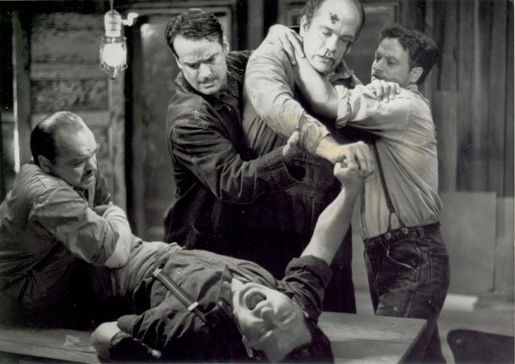
Power of Seduction

In Of Mice and Men, the power of seduction can be interpreted in two different ways. On one hand, it can be presented as the power of sexual attraction. On the other hand, it can be interpreted as the seduction of migrant workers by the American Dream.

The most obvious form of the power of seduction in the novel is Steinbeck’s portrayal of Curley’s Wife. Before we consider this, we must first consider the role of women in 1930s American society.

Women and Power

Women in 1930s USA did not have much power. They were unable to own anything and were reliant on their husbands to provide for them. Arguably, they only had one thing that they could own and sell – themselves.

Skim pp. 49-50, 53, 78-80. Write down all the words that are used to describe women. The first one has been done for you.
“purty” p. 49
How are women described in the novel?

There are very few women mentioned in Of Mice and Men. In the novel, the only women who are named are a prostitute (Suzy) and a dead woman (Aunt Clara). Curley’s Wife is referred to in such a way because Steinbeck does not give her a name.

Why do you think the only women in the novel are prostitutes, dead or going to die?

_________________________________________________________________________________

__________________________________________________________________________________

__________________________________________________________________________________

__________________________________________________________________________________

__________________________________________________________________________________

__________________________________________________________________________________

Curley’s Wife and Power
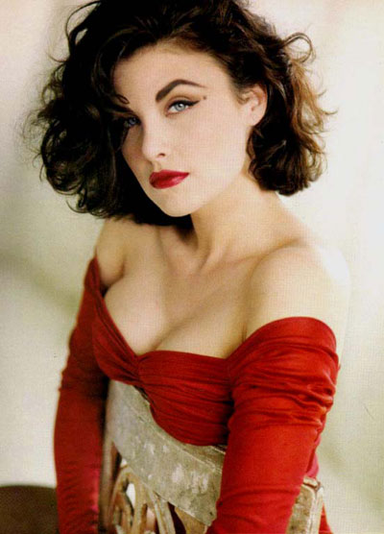
The only main female character in the novel is Curley’s Wife. She is the only female character who can speak for herself.

- Suzy the prostitute is only referred to and is never part of the action
- When Aunt Clara appears in the final section, she does not speak in her own voice, but rather speaks in Lennie’s. She is simply a figment of Lennie’s imagination.

What colour is Curley’s Wife associated with?

___________________________________________

This is symbolic of the danger of her passion. Steinbeck associates her with this colour to signal that she is a danger to George and Lennie.

Look at page 53. How is Curley’s Wife characterised? Consider her looks and actions. Is she portrayed in a positive or a negative way?

_________________________________________________________________________________

__________________________________________________________________________________

__________________________________________________________________________________

__________________________________________________________________________________

__________________________________________________________________________________

__________________________________________________________________________________

__________________________________________________________________________________

__________________________________________________________________________________

Curley’s Wife can be considered a caricature (a portrayal that exaggerates or distorts the essence of a person to create an easily identifiable likeness) of women in 1930s America. While she is portrayed as a woman who uses her sexuality and desirability to influence and exert power over others, she does face prejudice and discrimination common to women of the time.

Do you think that it is significant that Curley’s Wife is not given a name? What effect does this have on the reader’s interpretation of her character?

_________________________________________________________________________________

__________________________________________________________________________________

__________________________________________________________________________________

__________________________________________________________________________________

__________________________________________________________________________________

__________________________________________________________________________________

__________________________________________________________________________________

__________________________________________________________________________________

__________________________________________________________________________________

__________________________________________________________________________________

__________________________________________________________________________________

__________________________________________________________________________________

__________________________________________________________________________________

The American Dream and Power
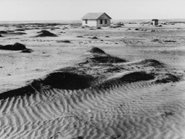

During the Great Depression of the 1930s, many men and women migrated from the American Mid-West to California in order to persue a new life and new opportunities. This was because of the Dust Bowl.

The Dust Bowl was caused by drought and farmers over-ploughing the land. The rich soils disappeared and were replaced by the dry, sandy soil underneath that was easily blown away.

John Steinbeck wrote about this in his 1939 novel The Grapes of Wrath:

"And then the dispossessed were drawn west- from Kansas, Oklahoma, Texas, New Mexico; from Nevada and Arkansas, families, tribes, dusted out, tractored out. Car-loads, caravans, homeless and hungry; twenty thousand and fifty thousand and a hundred thousand and two hundred thousand. They streamed over the mountains, hungry and restless - restless as ants, scurrying to find work to do - to lift, to push, to pull, to pick, to cut - anything, any burden to bear, for food. The kids are hungry. We got no place to live. Like ants scurrying for work, for food, and most of all for land."

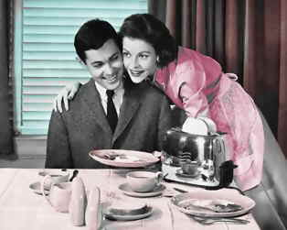
George and Lennie are typical examples of these migrant workers. They are drawn west by the power and seduction of the American Dream, the dream: “of a land in which life should be better and richer and fuller for everyone, with opportunity for each according to ability or achievement." - James Truslow Adams, The Epic of America, 1931

Why do you think George and Lennie’s dream of having “a little house and a couple of acres an’ a cow and some pigs” – and of course, rabbits – has such power over them?

__________________________________________________________________________________

__________________________________________________________________________________

__________________________________________________________________________________

__________________________________________________________________________________

__________________________________________________________________________________

__________________________________________________________________________________

__________________________________________________________________________________

Do you think that Lennie’s unwavering belief in the dream of living off “the fatta the lan’” is one of the most powerful elements of the novel? Why might this be?
__________________________________________________________________________________

__________________________________________________________________________________

__________________________________________________________________________________

__________________________________________________________________________________

__________________________________________________________________________________

__________________________________________________________________________________

__________________________________________________________________________________

__________________________________________________________________________________

__________________________________________________________________________________

__________________________________________________________________________________

__________________________________________________________________________________

__________________________________________________________________________________
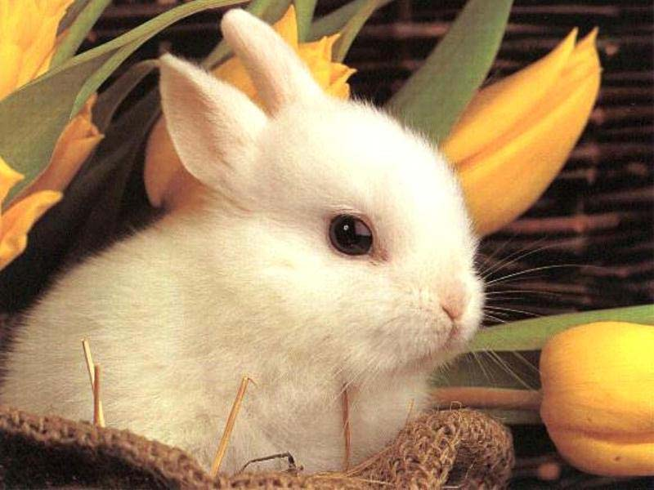
Power of Hierarchy

Hierarchy is defined as any system of persons or things ranked one above another. Hierarchy can be confined to a small space (such as a ranch) or can refer to an entire society or country.

Think about the hierarchy on the ranch. In each box, write the name of the character you think belongs in each branch of the hierarchy.

Characters: George, Lennie, Curley, Curley’s Wife, Slim, Carlson, Candy, Crooks, The Boss

Once you have completed the diagram, use the space given on the next page to explain your placement of each character.

__________________________________________________________________________________

__________________________________________________________________________________

__________________________________________________________________________________

__________________________________________________________________________________

__________________________________________________________________________________

__________________________________________________________________________________

__________________________________________________________________________________

__________________________________________________________________________________

__________________________________________________________________________________

__________________________________________________________________________________

__________________________________________________________________________________

__________________________________________________________________________________

__________________________________________________________________________________

__________________________________________________________________________________

__________________________________________________________________________________

__________________________________________________________________________________

__________________________________________________________________________________

__________________________________________________________________________________

__________________________________________________________________________________

__________________________________________________________________________________

__________________________________________________________________________________

__________________________________________________________________________________

__________________________________________________________________________________

__________________________________________________________________________________

__________________________________________________________________________________

__________________________________________________________________________________

__________________________________________________________________________________

Here is an example of an interpretation of hierarchy on the ranch. Yours may be slightly different.

The Boss

Slim

Curley

Curley’s Wife

Candy
Lennie
Carlson
George

Crooks

At the top is the Boss, the man who owns the ranch. He employs the ranch hands, and therefore has power over them – he can choose to employ them or he can choose to ‘can’ them.

Slim comes next, followed by Curley. He is described as “the prince of the ranch” even though Curley is the Boss’s son. Slim openly berates Curley for asking him where Curley’s Wife is when he says, ”Well you been askin' me too often” and also has the power to tell Curley to say his hand injury was caused when he got it “caught in a machine.”

After this things become more complicated. Women have little power in 1930s USA, however, it can be interpreted that Curley’s Wife comes next. She is married to Curley and therefore can exert some power over the ranch workers. However, the ranch workers do try to control her by telling her to go away, such as when Candy says, “you got no call foolin’ aroun’ with other guys, causin’ trouble.”

Undoubtedly at the bottom of the hierarchy is Crooks. As the only black man on the ranch, he is not even allowed to sleep in the bunk house, and instead “had his bunk in the harness room.”

Curley and Power

As suggested earlier, Curley should be the prince of the ranch, but instead that title goes to Slim. Curley is described as a “thin young man” who is “handy”. He is small, but is a good boxer. He is clearly intimidated by Slim and also finds it difficult to keep control of his wife.

On pp. 46-47, Curley displays hatred towards Lennie. Why do you think he does this?

__________________________________________________________________________________

__________________________________________________________________________________

__________________________________________________________________________________

__________________________________________________________________________________

__________________________________________________________________________________

__________________________________________________________________________________

Read pp. 89-94

Curley picks a fight with Lennie, but Lennie crushes his hand. Who has power here and in what form? Why does Slim tell Curley to say he got his hand caught in a machine? Why is he able to do this?

__________________________________________________________________________________

__________________________________________________________________________________

__________________________________________________________________________________

__________________________________________________________________________________

__________________________________________________________________________________

__________________________________________________________________________________

__________________________________________________________________________________

__________________________________________________________________________________

__________________________________________________________________________________

__________________________________________________________________________________

__________________________________________________________________________________

__________________________________________________________________________________

__________________________________________________________________________________

Racism and Power

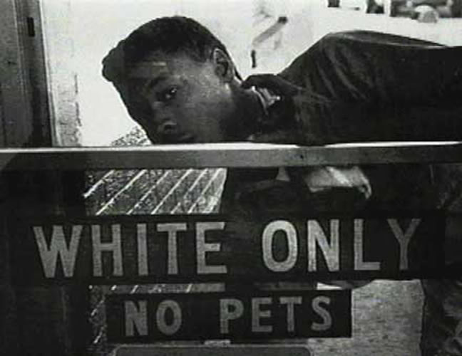
It is an unfortunate fact that until the Civil Rights movement in the 1960s, white people exerted an unnatural and unearned power over black people. In Of Mice and Men, Steinbeck explores racism and power through the character Crooks, who is the only black man on the ranch.

Nearly every character in the book is racist to Crooks because nobody talks or spends any time with him because he is black, which makes Crooks feel miserable since he has nobody to talk to. Furthermore, Crooks cannot even have his bunk in the bunk house with the other ranch hands. The Boss puts him in the “harness room” with the horses. Crooks is only separated due to his skin colour, and not because he has done anything wrong.

What is your opinion about Crooks being forced to sleep in the same place as animals? What do you think this says about the way he is considered by white people?

__________________________________________________________________________________

__________________________________________________________________________________

__________________________________________________________________________________

__________________________________________________________________________________

__________________________________________________________________________________

__________________________________________________________________________________

__________________________________________________________________________________

__________________________________________________________________________________

__________________________________________________________________________________

Being isolated from everybody makes Crooks unhappy and lonely because he has nobody to talk to and share his opinion with. This makes him bitter towards all of the white people because he feels they are the reason why he is lonely, and he is upset at the way they have treated him.

Crooks is very defensive around white people, and we can see this when Lennie visits Crooks in his shack. When all of the men left to go to the doctor to fix Curley’s hand Lennie wanted to stay with someone, so he decided to go to Crooks’ shack because there was a light on. Crooks did not want Lennie to stay and he said, “If you guys don’t let me in your house to play cards, why should I let you in mine?” Due to the way white people have treated Crooks, he would rather be lonely and sad than have a white friend.

Arguably, Lennie is the only non-racist white character in the book because he seeks Crooks out. It could be interpreted that Lennie does not have the intelligence to be racist. He sees things in simpler terms. He was lonely and perhaps scared when everyone left to fix Curley’s hand, so he sought out human company where he could find it. It would not have occurred to Lennie not to talk to Crooks just because he was black.

Answer the following question: how does Steinbeck explore the theme of power through racism in the novel? Look at pp. 40-41 and 98-102 to help you.

__________________________________________________________________________________

__________________________________________________________________________________

__________________________________________________________________________________

__________________________________________________________________________________

__________________________________________________________________________________

__________________________________________________________________________________

__________________________________________________________________________________

__________________________________________________________________________________

__________________________________________________________________________________

__________________________________________________________________________________

__________________________________________________________________________________

__________________________________________________________________________________

__________________________________________________________________________________

__________________________________________________________________________________

__________________________________________________________________________________
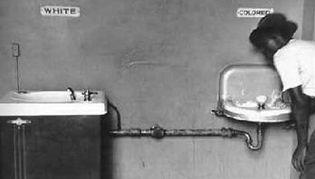
__________________________________________________________________________________

Statements to Consider

Based on the knowledge you have gained about power in Of Mice and Men, consider the following statements. What is your reaction to them?

‘Curley is the most powerful man in the ranch.’

__________________________________________________________________________________

__________________________________________________________________________________

__________________________________________________________________________________

__________________________________________________________________________________

‘Lennie only has physical power.’

__________________________________________________________________________________

__________________________________________________________________________________

__________________________________________________________________________________

__________________________________________________________________________________

‘Women in the novel are not powerful.’

__________________________________________________________________________________

__________________________________________________________________________________

__________________________________________________________________________________

__________________________________________________________________________________

‘Slim is the most powerful man in the ranch.’

__________________________________________________________________________________

__________________________________________________________________________________

__________________________________________________________________________________

__________________________________________________________________________________

‘Lennie is more powerful than George.’

__________________________________________________________________________________

__________________________________________________________________________________

__________________________________________________________________________________

__________________________________________________________________________________

‘Crooks is powerless in the ranch.’

__________________________________________________________________________________

__________________________________________________________________________________

__________________________________________________________________________________

__________________________________________________________________________________

‘Lennie’s dream is the most powerful element of the novel’.

__________________________________________________________________________________

__________________________________________________________________________________

__________________________________________________________________________________

__________________________________________________________________________________

‘George is more powerful than Lennie.’

__________________________________________________________________________________

__________________________________________________________________________________

__________________________________________________________________________________

__________________________________________________________________________________

Emotional intelligence is more powerful than physical strength.

__________________________________________________________________________________

__________________________________________________________________________________

__________________________________________________________________________________

__________________________________________________________________________________
