

Unit 1 booklet

Understanding and producing non-fiction texts

Date of exam: 29th May 2012
Time allowed: 2 hours 15 minutes
Section A: reading (40 marks)
Section B: writing (40 marks)

15 minutes- reading through the paper and the articles
1 hour- Section A
1 hour- Section B

Section A- Reading non-fiction texts

Unit 1 Assessment Objectives (AO2):

I. Read and understand texts, selecting material appropriate to purpose, collating from different sources and making comparisons and cross-references as appropriate.

III. Explain and evaluate how writers use linguistic, grammatical, structural and presentational features to achieve effects and engage and influence the reader, supporting their comments with detailed textual references.

Section A will test your ability to:

Read and understand texts
Select material from texts
Compare texts
Identify linguistic and presentational devices
Explain the use and effects of linguistic and presentational devices
Evaluate the effectiveness of linguistic and presentational devices
Use evidence from the text to support your points

On section A, you will have to read three texts and answer five questions.

Question 1 refers to Source 1, and will be a straightforward test of your ability to find information in the text.
Question 2 also refers to Source 1. This will test your ability to retrieve, understand and interpret information and ideas from the source.
Question 3 refers to Source 2, and will test your ability to understand and interpret meaning in the text.
Question 4 refers to Source 3 and will test your ability to write about the effectiveness of language employed by the writer.
Question 5 refers to any two of the sources. The question will test your ability to write about presentational features and to compare two texts.

Question one- Finding information in the text

Question one will test your ability to find information in the text.
It is worth 4 marks.

Example:

Read Source 1, the online holiday brochure for a trip to New York called guardian holiday offers
and answer the questions below.
1 List four activities you can do in New York. (4 marks)
1. ....................................................................................................
2. ....................................................................................................
3. ....................................................................................................
4. ....................................................................................................

How will this question be marked?

Give one mark to each of the following possible answers up to a maximum of 4.

Indicative Content
Answers may include:
stay at the Grand Hyatt Hotel on 42nd Street
visit the Empire State Building
take a walk in Central Park
take the ferry to Staten Island
watch a Broadway show
go shopping in famous stores
buy Christmas presents for friends and family

*Do not accept activities done on board the ship.

You will be awarded one mark for each point that you correctly identify.

Tips
- Look for numbers- this may help you with dates/times/amounts
- Look for capital letters- these will tell you the names of people and places
- Read the question carefully
- Do not leave any blank spaces on this question

Question two- Finding, understanding and interpreting information from a text

Question two will test your ability to understand the text, make relevant points and support these points with quotes from the text.
It is worth 4 marks

Example:

What do we learn about the ship Queen Mary 2 (QM2)? (4 marks)

How will this question be marked?

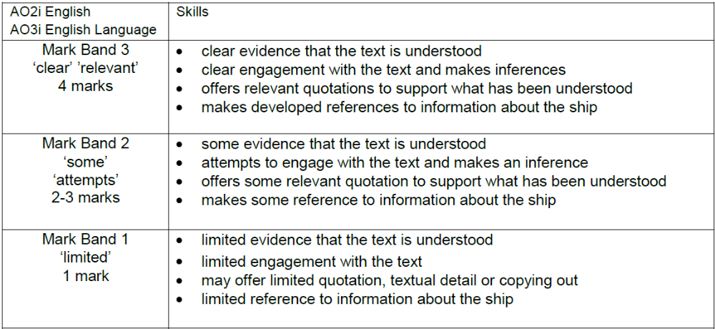

The examiner will give you a maximum of four marks for this question.
You need to show:
- You have understood the text
- You make reference to the text when answering the question
- You support your points using quotes
- You can select relevant information from the text

Tips:
- Use quotation marks (“….”) when using information from the text.
- Make clear points about the text.
- Explain/comment on the quote from the text.
- Do not copy from the text without providing further explanation.

Question 3-understanding and interpreting meaning in the text

This question will test your ability to understand the text and explain it in your own words. This question is based on Source 2.
It is worth 8 marks.

Example:

Now read Source 2, the charity webpage Sponsor a girl today and answer the question below.

What reasons are given to persuade the reader to sponsor a girl? (8 marks)

How will this question be marked?

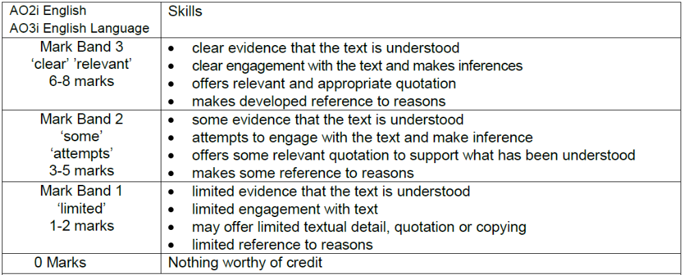

The examiner will give you a maximum of eight marks for this question:
You will need to show:
- You have understood the text
- You make reference to the text when answering the question
- You support your points using quotes
- You can select relevant information from the text

This is the same as question two, but to get 8 marks, you will need to make more points.

Tips:
- Use quotation marks (“….”) when using information from the text.
- Make clear points about the text.
- Explain/comment on the quote from the text.
- Do not copy from the text without providing further explanation.

Key phrases for answering questions two and three

Make your point
The writer of the text tells us that……
In the text, we learn that……
From the text, we learn that……

Support your point with evidence from the text
This is shown in the phrase “…………………………”
We know this because the text tells us “…………………………”
The line “……………………………” shows us this.

Explain/comment on the quote from the text
This tells us that……
This shows that……
This quote is evidence that……
This reveals that……

Question four- the effectiveness of language

Question 4 refers to Source 3 and will test your ability to write about the effectiveness of language employed by the writer. You will need to be able to pick out specific features of language and comment on their effect on the reader. It is worth 12 marks
Example:

Now read Source 3, an extract from an advice leaflet called Getting on with your Teenager and answer the question below.
How does the writer use language:
- to inform the reader about teenagers and
- to advise parents and carers?
(12 marks)

How will this question be marked?

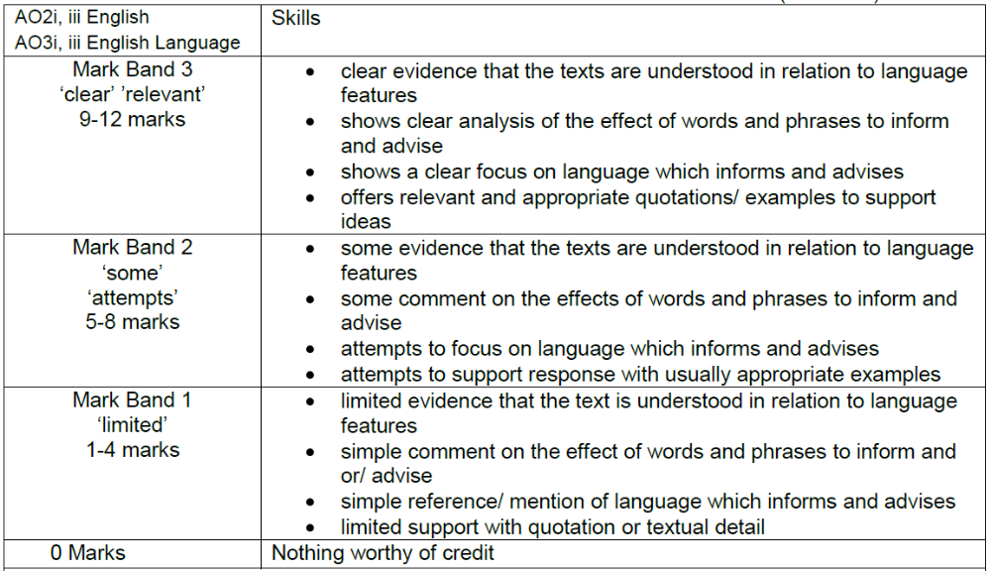

In your answer, you will need to:
- Show that you understand the text
- Analyse how language is used in the text
- Refer to specific language devices
- Write about the effect of these language devices on the reader
- Use quotes to support your answers
Language Devices

It is important that you can write about why the writer has used the language devices and the effect that the language devices produce on the reader.

Look at the table below. Match the devices with the reasons why they are used and the effect they produce on the audience.

Device | reason used by writer | effect produced on audience
alliteration

direct address

statistics

repetition

List of three

imagery

humour
similes and metaphors

rhetorical question

It creates a sound effect the reader will consider an issue more carefully The article feels more personal to the reader
To make the reader feel as though they are speaking directly to them to give more detail
To emphasise a particular word a particular word or phrase is made to sound important to make a comparison between two things
To paint a picture in the reader’s head To make the reader think
The reader can imagine something clearly to make the reader laugh and retain interest They will enjoy reading the article more
the reader has a clearer image of something It creates either a soft or a hard sound when the reader is reading
they have more information

Question 5-Comparing presentational features of two of the three texts

Question 5 refers to any two of the sources. The question will test your ability to write about presentational features and to compare two texts. You will need to pick out specific presentational features from two of the three texts. You will then need to compare the presentational features in these texts.
This question is worth

Now look again at all three sources. Choose two of these sources and compare the
presentational features.
I have chosen source .......... and source ...........
Remember to:
- write about the way the sources are presented
- compare how they look. (12 marks)

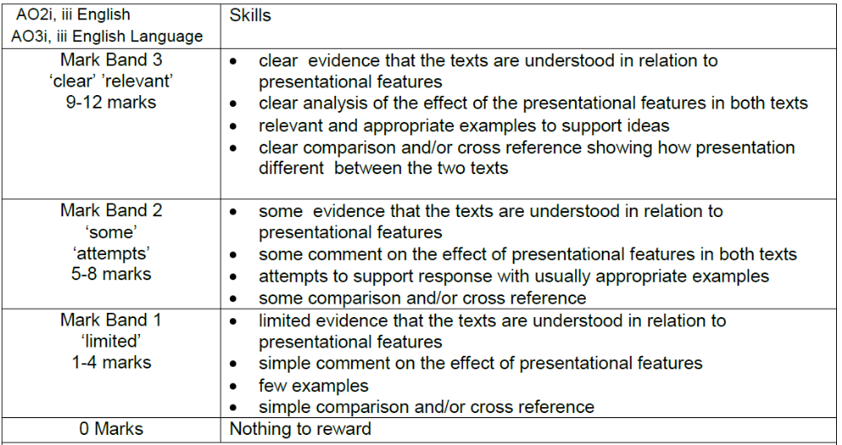

In your answer, you will need to:
- Show that you understand the text
- Analyse how language is used in the text
- Refer to specific language devices
- Write about the effect of these language devices on the reader
- Use quotes to support your answers
- Make clear comparisons between two of the texts.

Presentational Devices
presentational device | How does it help with advertising?
Headlines

Bold print, italics, underlining

Logos and slogans

Different size fonts

Use of colour

Use of charts, diagrams, graphs

Bullet points

Sub-headings

Celebrity

Slogans

It can create a mood. It can make the product more memorable.
It makes certain words or phrases stand out. It makes the purpose of the article clear.
It can make us take a product more seriously.
They present information clearly. They show where to find information in a text.
It can present information clearly. It makes important words stand out.
They make the product more identifiable.

Useful phrases for questions 4 and 5.

Which presentational/language device has been used
The uses ______________________.
__________________ has been used in this text.

Example
An example of this is …………
This is shown through the use of ………

Why the device has been used
The writer has chosen to use this device because......
This device has been used because……

The effect of the device on the reader
This device will make the reader feel……
The use of _____________ will make the reader……

Useful words for comparing texts

Similarities | Differences
Also…  And…  In the same way…  Equally…  Similarly…… | However…  On the other hand…  But…  Whereas…  By contrast……

Practice 1

Source one
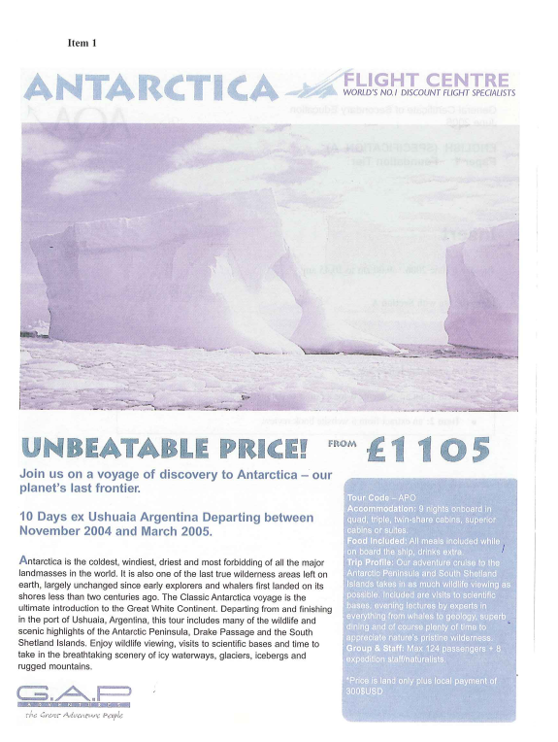

Source two

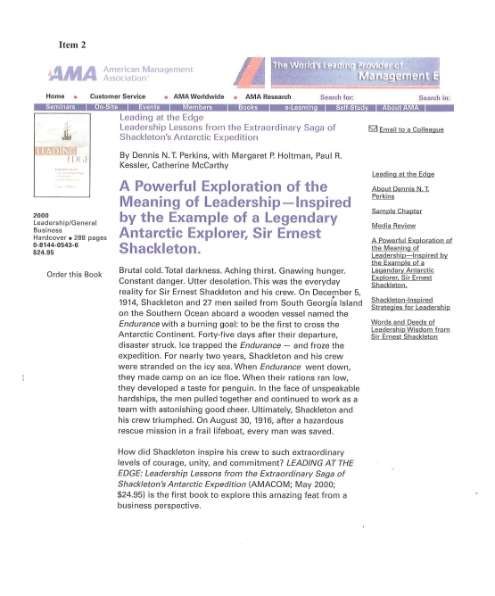

Complete these questions on paper/in your book.

- List four things that source one tells you about Antartica. (4 marks)

- What reasons does the article give for visiting Antartica? (8 marks)

- Read source 2.
What reasons does the article give for Shackleton’s difficult trip to Antartica?
(8 marks)

- Read source one again. How does the article use language to persuade the reader to buy a holiday to Antartica? (12 marks)

- Now look again at the two sources. Compare the presentational features.
I have chosen source .......... and source ...........
Remember to:
- write about the way the sources are presented
- compare how they look. (12 marks)

Practice 2
Source one
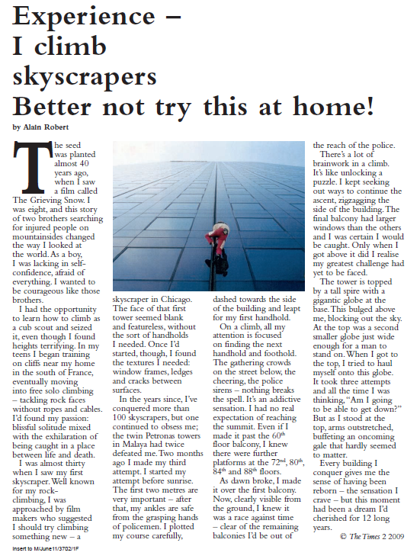

Source 2
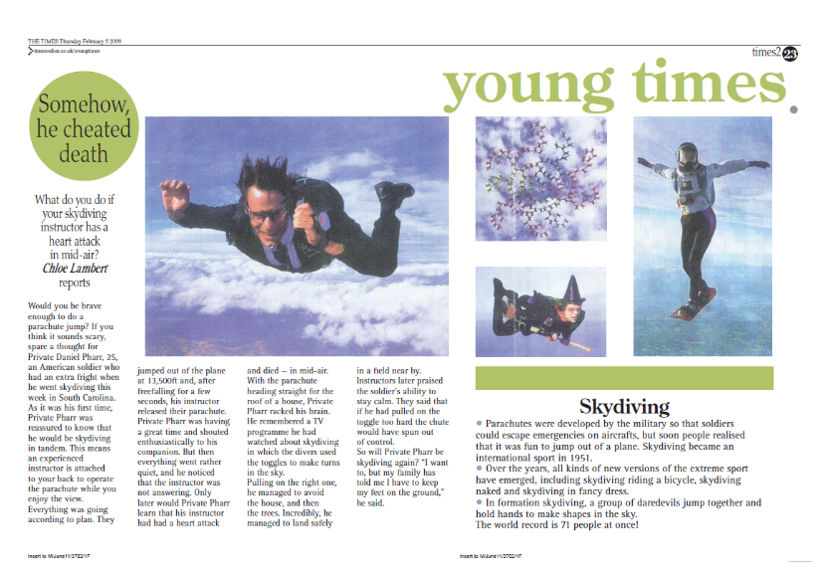
Complete these questions on paper/in your book.

- List four things that source one tells you about Alain Robert. (4 marks)

- What reasons does Alain Robert give for enjoying climbing sky-scrapers? (8 marks)
- Read source 2.
What reasons does the article give for trying skydiving? (8 marks)
- Read source two. How does the article use language to persuade the reader to try skydiving? (12 marks)

- Now look again at the two sources. Compare the presentational features.
Remember to:
- write about the way the sources are presented
- compare how they look. (12 marks)

Practice 3
Source one

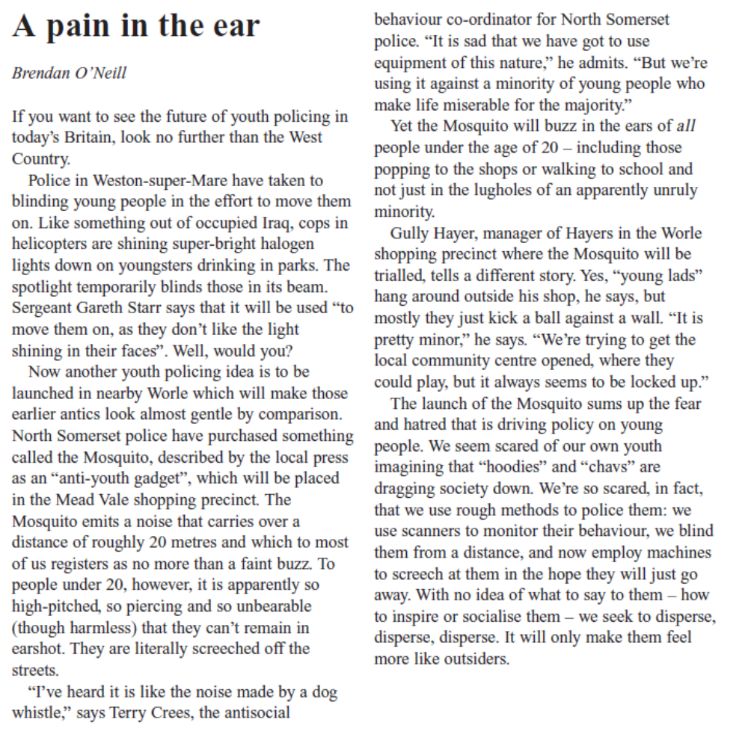

Source 2
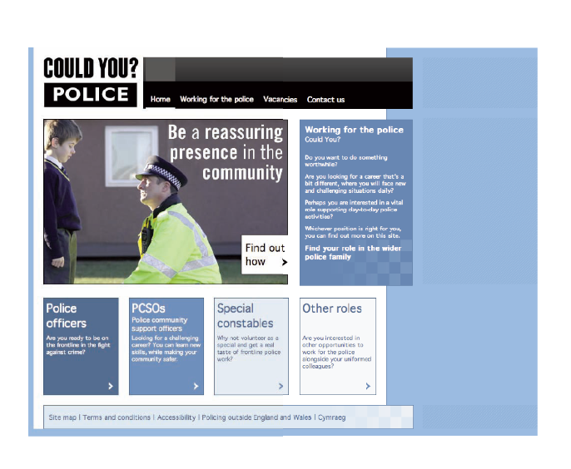

Complete these questions on paper/in your book.

- List four things that source one tells you about the methods that police are using in Weston-Super-Mare. (4 marks)

- What is the writer’s attitude towards the methods being used? (8 marks)
- Read source 2.
What information does it give you about the police? (8 marks)
- Read source two. How does the article use language to persuade the reader to join the police? (12 marks)

- Now look again at the two sources. Compare the presentational features.
Remember to:
- write about the way the sources are presented
- compare how they look. (12 marks)

Practice 4
Source one
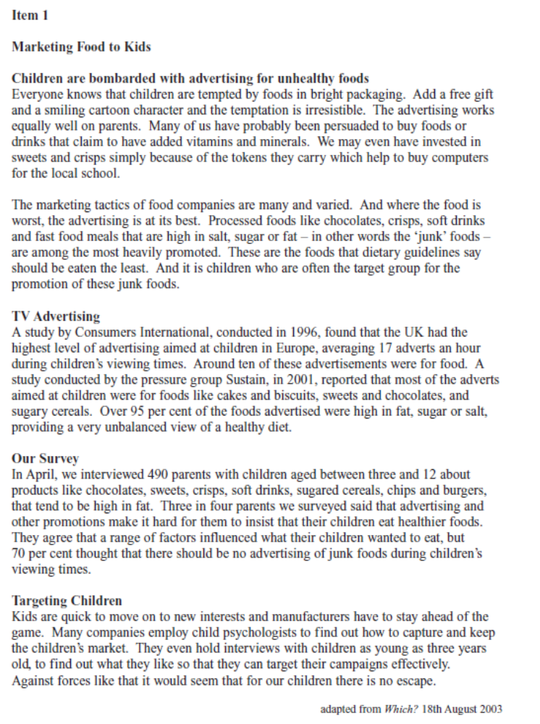
Practice 2
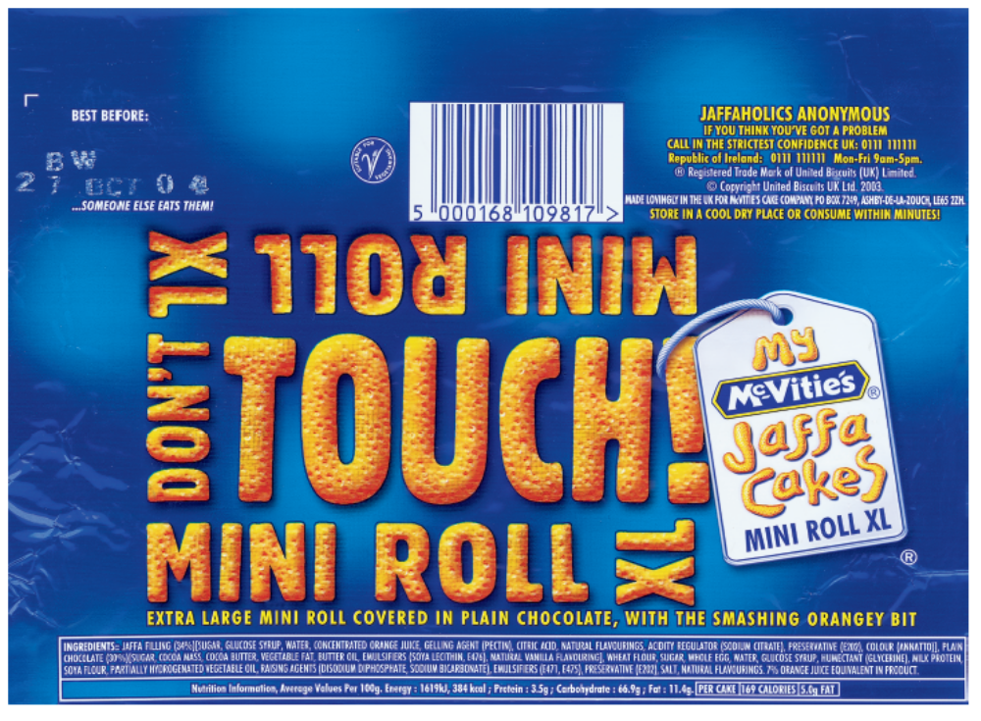
Complete these questions on paper/in your book.

- List four things that source one tells you about the methods that are used to advertise food. (4 marks)

- What is the link between advertising and children eating unhealthy food? (8 marks)
- Read source 2.
What information does it give you about the product? (8 marks)
- Read source two. How does the article use language to persuade the target audience to buy the product? (12 marks)

- Now look again at the two sources. Compare the presentational features.
Remember to:
- write about the way the sources are presented
- compare how they look. (12 marks)

Practice 5
Source one
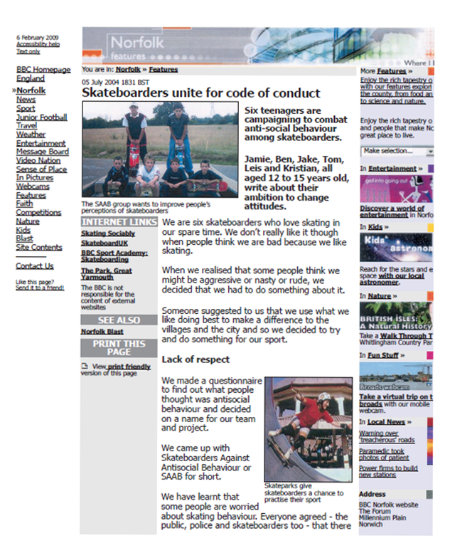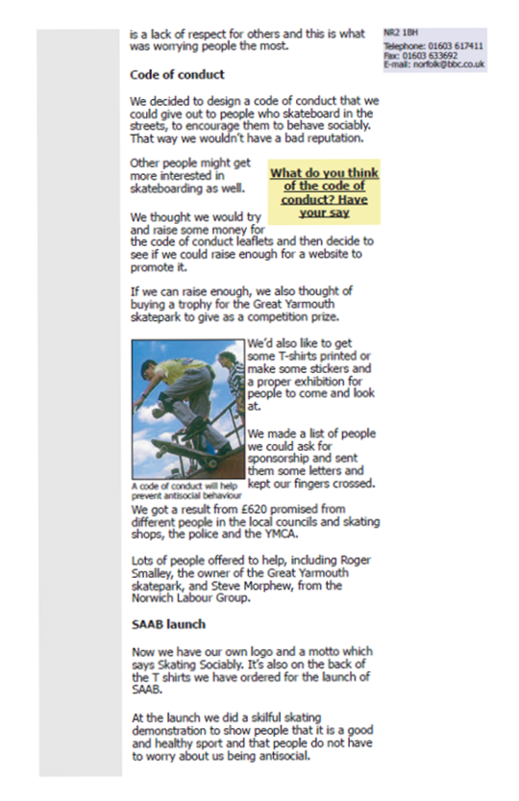
Source two
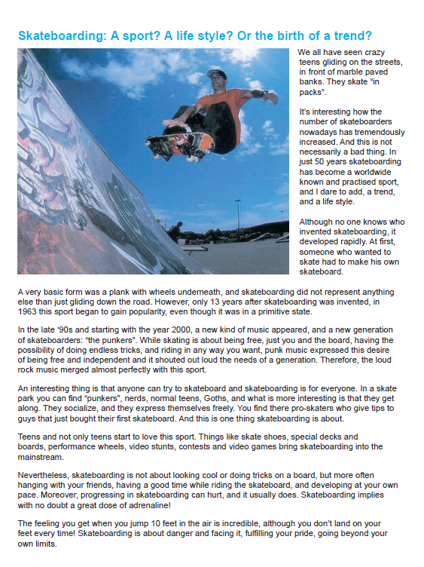

Complete these questions on paper/in your book.

- List four things that article tells you about Skateboarders Against Antisocial Behaviour. (4 marks)

- How did the teenagers set up their group? (8 marks)
- Read source 2.
What information does the article give about skateboarding? (8 marks)
- Read source two. How does the article use language to inform the reader about skateboarding? (12 marks)

- Now look again at the two sources. Compare the presentational features.
Remember to:
- write about the way the sources are presented
- compare how they look. (12 marks)

Section B- Producing non-fiction texts
On section B, there will be two writing tasks, one shorter and one longer. The shorter task will ask candidates to write to inform, explain or describe; the longer task will require more developed and sustained ideas which argue or persuade. Candidates will be required to adapt their style to fit audience and purpose.

How will I be assessed?
You will be given two marks for each task; one mark for communication and organisation of ideas, and one mark for skills.

You will be assessed on your ability to:
- communicate clearly
- put detail in to work
- answer the question properly
- write for the correct audience
- use appropriate language devices
- use effective and varied vocabulary
- use discursive markers (Firstly……, Secondly……, Then……, Lastly……)
- structure your work correctly using paragraphs
- use good grammar
- use a range of punctuation correctly
- use a variety of different sentence structures
- spell words correctly

The first task will be marked out of 16.
The second task will be marked out of 24.
You should spend approximately 25 minutes on the first task and 35 minutes on the second task.

Language devices for section B

Device | Definition | Example | Argue | Persuade | Inform | Explain | Describe
Direct address | Addressing the reader directly using the word “you” | You really need to reconsider your opinion about skateboarders. | ✓ | ✓ | ✓
Emotive language | Using specific words to make the reader feel happy/angry/sympathetic… | Think of all the poor, neglected animals that need your help. | ✓ | ✓
Facts/statistics | Factual information about a topic/percentages and figures | 80% of parents buy unhealthy food for their children. | ✓ | ✓ | ✓ | ✓
opinions | Your own ideas and opinions on a particular issue | In my opinion, advertising encourages children to eat junk food. | ✓ | ✓
List of three | Describing something using three adjectives to give more information | The food that most children eat is unhealthy, expensive and full of fat. | ✓ | ✓ | ✓ | ✓ | ✓
Anecdote | Writing about your personal experience | I, myself, used to watch adverts and want junk food when I was younger. | ✓ | ✓ | ✓
Senses | Writing about what you can see/smell/taste/touch/hear | You can smell the salt in the air and hear the crashing of the waves. |  |  |  |  | ✓
Interesting/powerful  Adjectives/adverbs | Describing something using interesting words | You can see the amazingly vibrant colours of the flowers | ✓ | ✓ |  |  | ✓
Similes and metaphors | Comparing one thing to another, either by using the words as/like or saying one thing is another thing | The sea sparkles like a precious sapphire. | ✓ | ✓ |  |  | ✓
Rhetorical questions | Asking a question to make the reader think | Could you join the police? | ✓ | ✓
Expert opinion | Giving an example of the opinion of a specialist to back  up your points | Professor White of Brentside University says that 90% of young people eat junk food at least once a week.

Practice writing tasks



