Aim Higher: Achieving an A – A* in the English Literature Exam

Year 11 Revision Booklet and Further Reading
Are you aiming for an A-A* grade in English Literature?
Are you interested in English Literature at A Level?
Use this revision booklet and further reading to extend your understanding of our key texts for the exams and prepare for A Level English.

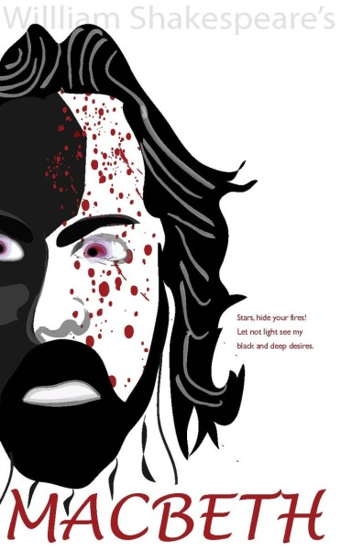
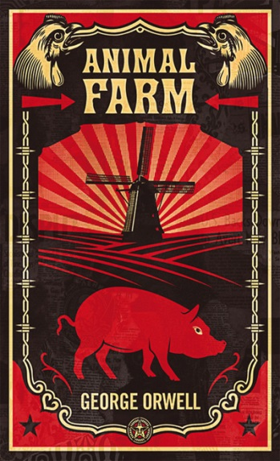

Macbeth
Animal Farm
Of Mice and Men
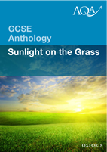
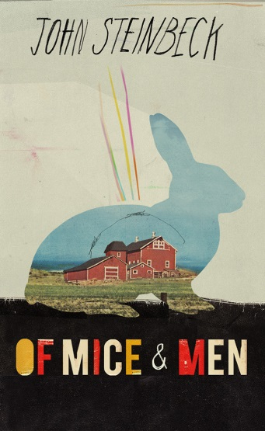
Short Stories

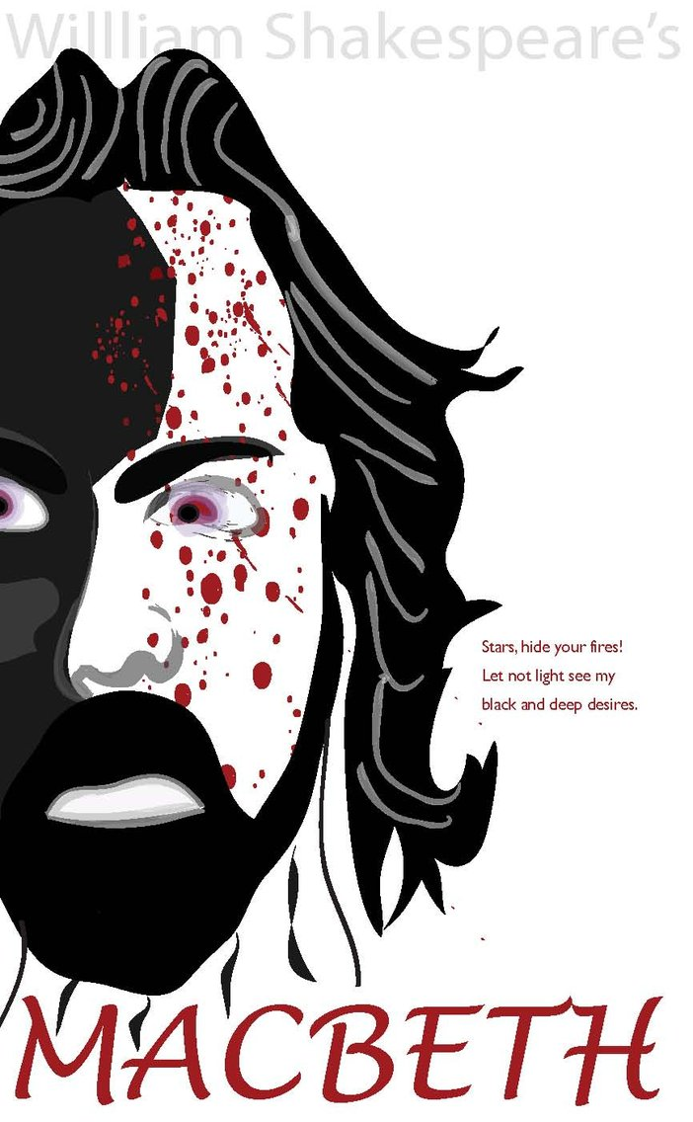
Macbeth by William Shakespeare
Unit 4: Approaching Shakespeare and the English Literary Heritage (35%) One exam paper of 1.5 hrs

Macbeth (20%)

50 mins on two short essays worth 30 marks. You will be given an extract to analyse, then you choose your own for a similar question.
The following pages contain articles, model essays and further reading on Macbeth. You can use them in the following ways:
- Highlight and annotate with the markscheme
- Transform into mind maps
- Use to plan and answer past paper questions
- Make detailed revision notes
Useful Revision Websites:
http://cherwellenglish.typepad.com/cs110/gcse-english-literature/
http://www.pearsonschoolsandfecolleges.co.uk/Secondary/Literature/Shakespeare/LongmanSchoolShakespeare/Samples/Samplepagesfromtheneweditions/SamplepagesfromMacbethAssessmentpracticesection.pdf
http://nfs.sparknotes.com/macbeth/
http://www.shmoop.com/macbeth/

English Literature: Banquo in Macbeth
Banquo is sometimes overlooked because people tend to focus more on Macbeth and Lady Macbeth. However, in a question about good v. evil in the play, it is interesting to note that alongside Duncan, Banquo is presented as a kind and virtuous character. This also leads to interpretations that Macbeth and Banquo are gothic doubles of the same character.
Contextually, you could argue that the only reason that Banquo is presented so virtuously is because he was allegedly loosely related to James I, who was the king at the time of writing and who was a big fan of Shakespeare's stuff.
We first meet Banquo in act one scene three, alongside Macbeth. Immediately the difference between the two characters is obvious when they are confronted by the witches. Banquo appears cool and collected, challenging them ("You should be women, / And yet your beards forbid me to interpret / That you are so.") and shrugging off their prophecy, while noticing how Macbeth is "rapt withal" at the witches' prophecy. Banquo also says the line "why do you start, and seem to fear / Things that do sound so fair?" The fact that Banquo is echoing Macbeth's first line, "So foul and fair a day I have not seen", may suggest that he represents one side of Macbeth - the 'fair' side. Is Banquo fair whilst Macbeth is foul?
Also, once the witches have disappeared and Angus and Ross turn up, Banquo speaks aside to the audience upon learning that Macbeth has been appointed as the Thane of Cawdor. He questions, "what, can the Devil speak true?" By immediately referring to the witches as being associated with the devil, Banquo appears to be distancing himself from such 'evil' and thus appears to be distancing himself from Macbeth, who was so taken with the prophecy.
Banquo also appears to be more wary, cautious and perhaps sensible than Macbeth. Macbeth appears instantly taken with the notion that he is destined to be king, whereas Banquo warns him that sometimes "the instruments of darkness tell us truths". Banquo is immediately set up as the opposite of Macbeth; he is loyal, kind and rational - Macbeth, on the other hand, appears to be immediately taken with the "supernatural soliciting".
Banquo also says to Ross and Angus, "New honours come upon him, / Like our strange garments, cleave not to their mould / But with the aid of use." This clothing imagery echoes Macbeth's previous line, "why do you dress me / In borrowed robes?" It suggests that Banquo is already aware that Macbeth's new title doesn't sit well with him.
Banquo also appears alongside Duncan in act one scene six, where both of them admire the castle of Macbeth, basically chatting about how lovely and homely it looks. This brings the use of setting into the theme of deception, and Lady Macbeth's arrival and duplicitous language sets the Macbeths up against Banquo and Duncan; the two virtuous characters are the ones being tricked.
The beginning of act two sees Banquo alongside his son Fleance. As if we didn't think he was lovely enough already, he's now being presented as a doting father. This normal family dynamic juxtaposes the dysfunctional Macbeths (which sounds like a sitcom). Fleance is also "holding a burning torch" in this scene, which may be symbolic of he and Banquo bringing light (goodness, clarity, rationality) to darkness (supernatural, evil, irrationality).
Banquo uses religious imagery such as "there's husbandry in heaven" to set him up as a benevolent character, which contrasts with Macbeth's plan to violate the divine right of kings by murdering Duncan. He later pops up in act two scene three with another reference to God: "In the great hand of God I stand". He also mentions a "diamond" in this scene; diamonds were seen at the time to be talismans against witchcraft.
Macbeth also blatantly lies to Banquo in this scene, saying "I think not of them" when asked about the witches. Does Shakespeare use Banquo as a narrative device for the reader/audience to learn of Macbeth's gradual descent into tyranny and duplicity?
Banquo is also present at the beginning of act three, and once again makes reference to the "so foul and fair a day I have not seen" quotation by saying, "I fear / Thou play'dst most foully for't". He is suggesting that Macbeth may have achieved his goal through foul aims. He then entertains the idea of being the father of kings, if only for a moment - "If there come truth from them ... may they not be my oracles as well, / And set me up in hope? But hush, no more." It's only human, I suppose. This is still a relatively selfless desire of Banquo, too - he's interested in the fact that his sons will be kings.
Banquo's duties to the king appear as strong as ever: "Let your Highness / Command upon me, to the which my duties / Are with a most indissoluble tie / For ever knit." This juxtaposes Macbeth's loyalty to the divine right of kings, which is a bit sketchy to say the least.
Then, when Banquo leaves, the audience truly realises the extent of Macbeth's ambition, as he entertains the idea of 'removing' Banquo, to put it nicely. He says to the two murderers that Banquo is their enemy and "so he is mine", and appears focused on the "seeds of Banquo kings!"
Then, in the act that many would pinpoint as the moment where Macbeth loses most of the audience's sympathy, he tells the murderers to "leave no rubs or botches in the work, / Fleance his son, that keeps him company, / Whose absence is no less material to me / Than his father's, must embrace the fate / Of that dark hour." The scene ends with a rhyming couplet of: "Banquo, thy soul's flight, / If it find Heaven, must find it out tonight." This rhyming couplet suggests a sense of confirmation and finality - Macbeth is no longer um-ing and ah-ing over what he wants to do; he's going to have Banquo and Fleance murdered, no matter what.
In act three scene three, as the murderers attack Banquo and Fleance, it is important to note that one of the murderers "strike out the torch". The light that accompanies Banquo and his son has been extinguished - they have been defeated at the hands of Macbeth. And even as Banquo is struck down, his only concern is for his son: "Fly, good Fleance, fly, fly, fly!"
Then we see Banquo as a ghost in the next scene - or, rather, Macbeth sees Banquo's ghost. This ghost is often interpreted to be a manifestation of Macbeth's guilt as opposed to any real supernatural ghost. Macbeth has now killed the two most virtuous characters of the play, one of whom he called a "friend" earlier in the play. When comparing this to his earlier scenes with Banquo, we are made aware of the shocking extent of his descent into tyranny.

Macbeth - The Witches
One of the most memorable aspects of Shakespeare's Macbeth is the presentation and use of the three witches. They are typically Gothic, they develop the plot and the ambiguity surrounding them means you can talk about them in an exam without being limited to one or two interpretations.
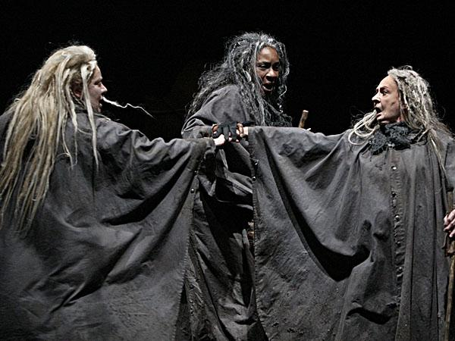
The Witches - Context
Contextually, there's a lot to say about the witches. The play was written shortly after James VI of Scotland's succession to the throne, making him King James I. James was particularly interested in witches and believed in them so vehemently he decided to write a whole book on witches in 1597 (it was a slow year).
The book, Daemonologie, highlighted his insistence that witches existed and wielded supernatural powers. He took influence from the Bible, and he once blamed stormy seas on witches, because they were pretty much the perfect scapegoat for anything.
Shakespeare's witches are similar to the witches James spoke of so often. This, combined with the fact that James I was a big fan of Shakespeare's stuff, suggests that a huge source of inspiration for the characters was King James I himself.
So in an essay, you can use this contextual knowledge to form an interpretation that is contrary to your point; if an exam asks whether the witches are manifestations of Macbeth's guilt/products of his imagination/etc., you can provide the interpretation that the witches may just be included to appease King James I. I'd only go for this line of argument as a separate interpretation, though - I think to consider it and reject other interpretations provides a slightly narrow view on the play. But that's just me.
First Appearance/Interpretations
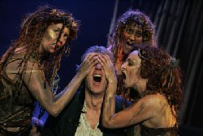
It's interesting to note that the play opens with the witches, and you can talk about this in terms of the play's structure. Do the witches frame the play, like Walton frames Frankenstein and Lockwood frames Wuthering Heights? (Of course not in the same way as the other two texts, but you get my point.) By 'framing' the play in such a way, are we to expect that they have control over the events of the play and what happens?
The first scene is very short, but establishes one of the most important quotes in the play (when I say 'most important', it's all subjective. Shakespeare didn't outline ten quotes at the end of each performance and say 'I hope you all noticed these ones, they were really clever'):
"Fair is foul, and foul is fair;"

This line is echoed by Macbeth - and it's actually his first line in the whole play:

"So foul and fair a day I have not seen."

So what does this mean? The echoed line may indeed suggest that the witches are in control of Macbeth - and if they control him, how can he be to blame? If an exam asks whether Macbeth cannot by sympathised with/is a cold-hearted villain/etc. then you can argue that he is none of these things because he has no freedom over his actions.

You could also argue that the echoing of this line enforces the interpretation that the witches are figments of Macbeth's imagination or are manifestations of his inner conflict. Alternatively, you could argue that the link between Macbeth and the witches blurs a line between "worthy Macbeth" and the 'evil' witches - perhaps suggesting that there is a darker side to the character who has been set up as a valiant hero. Later on the witches learn of Macbeth's imminent arrival and say:

"something wicked this way comes"

A phrase you may have heard from the novel or even from this. Anyway, the fact that Macbeth is called "wicked" by the witches is interesting, and not just in the omg-that's-rich-coming-from-three-witches way. If the witches are as hideous and evil as Shakespeare arguably presents them, what does it say about Macbeth that they consider him 'wicked'?

Furthermore, the witches aren't the only ones associated with the unnatural. Once Macbeth has killed Duncan, violating the divine rights of a king, it is said by the Old Man in 2,4 that nature has pretty much fallen apart. This notion of one man's actions rippling across the natural world is typical of a tragedy, and the violation of nature thanks to Macbeth's actions links to the witches, who are essentially the definition of unnatural.

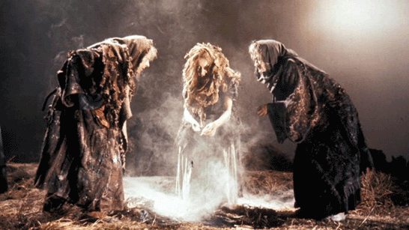
Gothic Nature/Supernatural Elements/Links to Lady Macbeth

The witches themselves are, of course, very Gothic. This is obvious from the moment Macbeth and Banquo lay eyes upon them:

"look not like th'inhabitants o'th'earth"

"You should be women, / And yet your beards forbid me to interpret / That you are so."

Firstly, the fact that the witches look otherworldly adheres to the Gothic aspect of the supernatural. Of course the witches are ridiculously supernatural in pretty much every way (prophecies, witchcraft, apparitions etc.). But what is also interesting is the fact that in terms of appearance, the witches seem to be a blur between male and female. They "should" be women, yet aren't - not quite. You could possibly link this to Lady Macbeth's "unsex me here" speech - is Lady Macbeth trying to emulate the androgynous nature of the witches? By removing her femininity, which constrains her, is she becoming more witch-like? The fact that the witches should be female but aren't doesn't only highlight the blurring of boundaries that is so common with Gothic texts, it also takes what is usually the womanly, protective and maternal role and violate it horribly, just as Lady Macbeth does when she goes on about dashing a baby's brains out.

It's also interesting to note how Macbeth and Banquo differ in their reactions upon seeing the witches, but that's got more to do with those characters, who I'll probably cover separately. Still, it's worth noting that Banquo basically gets all sassy whereas Macbeth practically starts drooling at the prospect of becoming king. Does this say something about the witches being manifestations of Macbeth's inner desires, perhaps?

Furthermore, it's interesting to highlight the similarities - as I already have done, albeit fleetingly - between the witches and Lady Macbeth. Macbeth isn't the only one who echoes the witches. In 1,3 the witches say:

"All hail, Macbeth! That shalt be King hereafter!"

And in 1,5 Lady Macbeth greets Macbeth with:

"Great Glamis! Worthy Cawdor! / Greater than both, by the all-hail hereafter!"

I don't need to spell it out - the links between them aren't by any means tenuous. Is Lady Macbeth a 'fourth witch', as some critics suggest? It's also interesting (and I've only just though of this - I love English Lit) that Macbeth's first line is an echo of the witches, and Lady Macbeth's first line to Macbeth is an echo of the witches. The witches seem intrinsically linked to Macbeth, whether the links are explicit or implicit.

Apparitions

You can also talk about the witches and link it back to AO2 (form, structure, language). They quite frequently speak using iambic rhythm and rhyming couplets. This gives them an eerie, supernatural unison that sets them aside from humanity and presents them as more of a collective 'force' - it also strengthens the interpretation that they are linked to Macbeth, since their language arguably makes them sound like an idea/concept rather than three individual characters. They also frequently use animal imagery which sets them apart as uncivilised/savage - and arguably links to the hunting imagery used to describe Macbeth at the beginning of the play.

This language pattern is also picked up by Macbeth in the latter half of the play; his language becomes more destructive:

"Even till destruction sicken: answer me / To what I ask you."

It starts to pick up on the rolling rhythm of the witches:

"you secret, black and midnight hags"

And some things he says are just inherently witch-like:

"I conjure you"

Also, his use of analepsis:

"Though bladed corn be lodged and trees blown down; / Though castles topple on their warders' heads; / Though palaces and pyramids do slope..."

Makes his language sound like something of an incantation.

This suggests that the witches have an influence on Macbeth throughout the entire play, and arguably strengthens the interpretation that they are controlling him.

What is also important about this scene is the use of the three apparitions that warn Macbeth of what is to come: an armoured head, a bloody child and a child carrying a tree/branch. It's interesting to note that the witches are not necessarily presented as 'evil' here. Macbeth demands something of them, so they conjure up the apparitions. If anything, the apparitions are to help Macbeth and warn him of what is yet to come - the witches take a back seat, as if they know their work is done. Perhaps they've influenced Macbeth enough to the point where they no longer need to provoke him, and know that his inflated sense of self will only spiral downwards into a bloody and tyrannical reign?

The “fiend-like queen” and her influence on the Gothic
Shakespeare needs this play to focus on gender in order to help to establish the patriarchal Jacobean monarch on his throne. He can not really write a series of weak females at this late stage in his career since for so many years he has been creating “masculine” heroines in order to win the favour of Queen Elisabeth. Lady Macbeth needs to be seen in light of what came before, as well as in the light of the direction that Jacobean theatre in general is moving – all the heroines of Jacobean tragedy seem to have a well developed ruthless streak.
Given this background, Lady Macbeth begins to slot into place. She is feminine in her care for Macbeth shown in 3.2 and again in 5.1 when her guilt has made her so remorseful that she is a tormented soul – all she chides Macbeth for in 3.4. She is wonderfully strong in Act 1 when reading the letter, but we are not really prepared for the shock of “unsex me here/and fill me…direst cruelty”. This prayer to the “spirits that tend on mortal thoughts” must be seen as the key to this character and to the writing that would follow later. Coming so early in the play, the prayer is directly linked to the Witches, themselves symbols of mixed gender and this wish to be unsexed must be considered.
Firstly, it is not a plea to be made male. Nor is it focused solely on her sexuality, since it makes demands on Macbeth as well. You will need to decide whether the wish for the spirits to “take my milk for gall” is a neutral act, or a genuine subversion of her femininity. If the wish is for a substitution – a denial of one of the defining characteristics of her gender - then the act is passive. If, however, you believe the idea that the line is an invitation for the spirits and “murdering ministers” to suckle at her breast, receiving her milk as their gall, then Lady Macbeth has moved considerably further away from a vague wish to exhibit more manly characteristics. In short, this wish to nurture the evil spirits would go some way to define her as a “fiend-like Queen”. After this debate, the advice she gives to her husband has a somewhat feminine quality – “bear welcome in your eye,/ your hand your tongue – a far cry from the violent warrior described in the opening scenes. This dichotomy increases in the course of Act 2 as Macbeth is repeatedly upbraided for his weakness. It seems natural that with his overpowering “milk of human kindness” the new Lady Macbeth should seek to goad him to action by criticising his unmanly behaviour. After all, hasn’t she just got rid of her own milk? Indeed in Act 1.7, between cries of “then you were a man”, she tells the tale of the suckling baby who she would rather “have plucked my nipple from his boneless gums / And dashed the brains out”. Again she focuses on her breasts as instruments of nurture denied and on the masculine child, thus establishing herself as stronger than the males in her circle at this time.
Macbeth is not at the bottom of the masculine table. Duncan sits below him, curiously for this character who needs to represent such a good king. In 2.1, when Macbeth is preparing to murder Duncan, he imagines himself approaching “with Tarquin’s ravishing strides”. This is a surprise since it immediately equates this murder with the rape of Lucretia, whilst at the same time linking Macbeth with Tarquinius Superbus, a Roman tyrant who would be murdered and removed from the throne after a bloody civil war. We seem to have a three part inversion here – the lowest status in contemporary society has attained the strongest position, and the highest is raped/killed by a man who is in thrall to his wife. This is a play where “fair is foul” and such reversal should not surprise.
Almost as soon as the murder is committed, Lady Macbeth begins to fade. We learn that Duncan “resembled (my) father as he slept” to an extent that she could not take the deed on herself. Furthermore, after smearing the grooms with blood, the knocking begins that will herald the transformation of the castle into a metaphorical hell and the pair retire, though not before Lady Macbeth chides Macbeth for his blood stained guilt – “go get some water…”. The irony is that this will be the lasting image of her in 5.1 as she sleepwalks, wracked with guilt. From this point her role recedes.
In the banquet (3.4) she attacks Macbeth repeatedly about what she perceives as his lack of manhood, and though she takes the male role by dismissing the guests, we see little of her strength or masculine cruelty. She has, in 3.2, been shut out of Macbeth’s plans as he begins to dominate the play and is left playing the traditional feminine role of concerned wife, albeit one whose concern stems from her fear that Macbeth will give away the secret of Duncan’s murder.
By the time we meet her in 5.1, her condition is so far gone that the Doctor says she “more needs… the divine than the physician”. As her mind wanders back through the play, the focus is on her guilt and on the need to take care of Macbeth, urging him to return to bed, much as she did in 3.2. It seems that for all the cruelty of the opening scenes, she is to die in a very unmasculine manner, if not a wholly feminine one, but certainly in a manner which leaves no trace on Macbeth when he is told the news. By the end of the play all women are dead and a patriarchal monarchy is established- one which is meant to thrive and produce the contemporary line of monarchs.
There is much here that is reflected in the Gothic writing you will encounter. The real difference seems to be in the willingness of the writers of the Eighteenth Century and beyond to allow their heroines to retain their strength throughout the piece. But it is relatively straightforward to trace the thematic links back to Lady Macbeth or to other heroines of this period in Shakespeare’s writing such as Goneril and Regan. Certainly we see a wish to subvert gender and a wish to dominate the males in the narrative, but there is little sense in Macbeth of a strand of Gothic writing that will develop – the entrapped or persecuted female or the male who perverts the natural order of things to establish a hold over a woman.
From this point, it is not a huge jump to the post-modern world of Angela Carter where two forms of female seen in Gothic writing can develop and emerge from one another. The first type as seen in much male writing is the passive or docile female, the second, the active and proactive-as seen in Lucy and developing from Lady Macbeth. Students are reading the Bloody Chamber and should look at the Tiger’s Bride to see the transformation clearly. At first the heroine describes how ““I watched with the furious cynicism peculiar to women whom circumstances force mutely to witness folly, while my father [...] rids himself of the last scraps of my inheritance.” Here we see a passive female, entrapped and at the mercy of her father – a classic Gothic construct. She is handed over to the Beast and it is here that a change from the usual trajectory of such writing takes place. This character will not fall in thrall to her male “owner” and nor will she be “saved”… Instead she willingly gives herself to the Beast and unleashes a violent sexual response from him until “each stroke of his tongue ripped off skin after successive skin, all the skins of a life in the world, and left behind a nascent patina of shining hairs. My earrings turned back to water and trickled down my shoulders; I shrugged the drops off my beautiful fur.” In the Twentieth century, the Gothic heroine is in control of her own destiny and wears her inner sexuality with pride. She does not need to be “unsexed” in order to triumph, instead she recognises her inner strength - the power of her gender.

Macbeth, the “dead Butcher”.
When Malcolm refers to Macbeth as a “dead butcher” (V.ix.35), the point is clear: the events of the play have been created and undertaken by a man with a driving blood lust and lack of respect for propriety. The play post dates Julius Caesar, a play in which the antithesis of butchery and beneficial sacrifice is laid clear by Brutus: “Let’s be sacrificers, but not Butchers, Caius” (JC II.i.173), “Let’s carve him as a dish fit for the Gods,/ Not hew him as a carcass fit for hounds (JC II.i 180/1). Allowing that Brutus is to be seen as the quintessential “honourable” man accepting the need for Regicide to cleanse and heal the state, Macbeth might well be seen as his polar opposite with Malcolm’s words merely serving to draw our attention to the fact. Shakespeare, as we might imagine, gives us much more – a rounded portrayal of a war hero who degenerates as his character becomes tainted with the illicit power suggested to him by the Witches.
The play opens with descriptions of warfare and of Macbeth’s performance on the field. There is a sense of anticipation built up as Shakespeare delays the first meeting with Macbeth and allows the King and his men to discuss his exploits in his absence: “For brave Macbeth (well he deserves that name), /Disdaining fortune…carv’d out his passage…Till he unseam’d him from the nave to the chops/ and fix’d his head upon our battlements” (I.ii 16ff). The Captain’s description of Macbeth’s heroics serve to show him as everything Duncan could wish – brave and heroic in defence of the Kingdom and even the description of the savage upper cut surely reflects the savagery of war, rather than plain butchery. We should notice, however, that he is “Valour’s minion” in this passage, “disdaining Fortune”. Perhaps here there are hints at what is to come? A minion often carries overtones of sexual exploitation by a stronger party (See Marlowe Edward II) and this together with the disdain in which Macbeth holds Fortune, may well suggest that his own character is not strong enough to withstand the pressure that it will be subject to. Duncan grants Macbeth the title of Thane of Cawdor and we await our first meeting with this military superman.
When the witches announce to Macbeth and Banquo that the elevation is at hand, Macbeth is far from confident – “Good Sir, why do you start, and seem to fear/Things which sound so fair? (I.iii 51)- and his reluctance to accept the information seems genuine, even as he realises the true import of what has been shown to be true: “This supernatural soliciting/Cannot be ill; cannot be good:-“ (I.iii 129) and begins to weigh up the true implications of what he has been told. Recognising that the murder which must be committed is abhorrent to nature, Macbeth decides that “Chance may crown me/ Without my stir.” (I.iii 144). This warrior, so adept in warfare seems curiously unwilling to wield his sword in a manner contrary to nature at this stage. Even when Malcolm is raised to the Prince of Cumberland and Macbeth calls for the “stars to hide your fires!” (I.iv 50), Macbeth acknowledges his “black and deep desires” but requires a catalyst for his actions.
Lady Macbeth can be that catalyst and in receipt of the letter in I.v sees at once the issue at hand: “Yet I do fear thy nature:/It is too full o’ the milk of human kindness” (I.v.16); Thou…Art not without ambition, but without/The illness should attend it” (I.v.19). She notes that he would act “holily” given the choice and sets out to turn her warrior-husband into the butcher described by Malcolm.
In the soliloquy in I.vii Macbeth, on the point of action, is still considering his deed. Lady Macbeth has convinced him of the need to act and to ensure that he appears trustworthy, yet his conscience still troubles him. “He’s here in double trust…” ( I.vii) begins a sequence of ideas that present themselves as reasons not to kill Duncan which Shakespeare balances with the good/evil antithesis which runs throughout the play. Even now, Macbeth is clearly aware of the “deep damnation” which his act will incur for Duncan (as well as for himself) and recognises that his only motive is “vaulting ambition”. At this point he is interrupted by the arrival of his wife who shores up his courage and sends him to do the deed, contemptuously adding that he might otherwise “live a coward in thine own esteem,/Letting “I dare not” wait upon “I would”…”. Her language is that of the “fiend-like Queen” as Malcolm describes her (V.ix 35) as she imagines how she would “while it was smiling in my face,/Have pluck’d my nipple from his boneless gums/And dash’d the brains out” urging Macbeth to act against “Th’unguarded Duncan” and “His spongy officers”. Her language is powerful and easily conveys the weakness of the prey. The speech is centered on the claim made by Macbeth to be a “man” She has already prayed to be unsexed and now Macbeth suggests that only male offspring are suitable for one such as her.
In Act II Macbeth’s subconscious still troubles him as he approaches the chamber, yet the deed is done, effectively but not completely, and he seems mentally unhinged when he meets Lady Macbeth on completion of the murder. It is she who takes the opportunity to murder the guards leaving Macbeth to wait in terror “whence is that knocking?” (II.ii 56). The knocking continues, linking the scenes and adding the subtext to the porter who will emerge like the porter of Hell, clearly rendering Macbeth’s castle into Hell itself. The new King of Hell, having “murdered sleep” seems trapped in agonies of guilt and an awareness of the moral implications of his actions. In II.iii 89ff “Had I but dies an hour before this chance…” Macbeth is given the chance to portray his innocence whilst telling anyone with knowledge of the crime committed the truth. He sees that his way is now clear and that there can be no turning back. As he tells the tale of the upper rooms the antithesis between Good and Evil re-emerges –Duncan’s skin is silver, “lac’d with his golden blood” and the stab wounds look like a “breach in nature”. There is no opportunity given from this point on for him to reflect on his acts or show remorse. Indeed the moral implications of the deed are not really the basis for his lack of impetus. To this point Shakespeare has given us a portrait of a man totally aware of the lack of motive for his action and struggling to overcome his qualms about acting in cold blood. After this, things will be different.
It seems that from this point Macbeth becomes obsessed with the need to kill to maintain his safety. Whilst Lady Macbeth becomes wracked with torment and guilt, he moves from one act to the next with a degree of certainty, even seeking to hide his actions from his wife lest she manages to dissuade him. That he needs to kill Banquo is obvious to him “To be thus is nothing, but to be safely thus:” (III.i46ff) and his soliloquy is driven by references to his jealousy and sense of injustice that Banquo’s offspring shall become Kings after him. Murderers are organised ( the confusion over the Third Murderer need not delay us here) and all is done without the driving of Lady Macbeth who is given one of the very few opportunities in this play to present a case with pathos. Her portrayal of the tormented and sleepless Macbeth is rudely brushed aside, however (“We have scorch’d the snake…”) and the scorpions in his mind lead him to the simple decision to carry on with his action. Lady Macbeth is shut out at this point and seems to be ignorant of the deeds, even when Macbeth is facing Banquo’s ghost at the banquet. Her response than harks back to her taunts in Act 1 as she cries, “What! Quite unmann’d in folly” and links Macbeth’s response to the lack of manhood perceived at the time of the murder of Duncan. As Macbeth is driven on to his next murder –“How say’st thou, that Macduff denies his person, At our great bidding?” she notes merely that he lacks “the season of all natures, sleep” (III.iv125ff).
When the witches conjure the apparitions in IV.i 70ff, Macbeth acknowledges that they have “harp’d my fear aright” acknowledging that his fear of Macduff is already strong, the parade of Kings stands more as a political gesture by Shakespeare than a further intensifying of the message. The murder is not carried out by Macbeth, but is in his name and Shakespeare focuses the audience on the death of a child – innocence being slaughtered. Against this background, Macbeth’s character is commented upon by Malcolm and Macduff in IV.iii as they discuss their country from the safety of the Saintly English King’s court. The country is described with a metaphor of the yoke and “each day a new gash is added to her wounds”(IV.iii 40), presumably by the butcher who now rules the country. As Malcolm seeks to show his unworthiness to rule, Shakespeare shows us the true nature of Macbeth: “black Macbeth”, “bloody, Luxurious, avaricious, false, deceitful, sudden, malicious” as he seeks to show his own weaknesses. Macduff will counter this and hold him as fit to rule before the news of his own loss is brought. After the pathos of the murder scene, the news is carried briefly, with little exaggeration of the deaths of the children and the wife. The message is juxtaposed with the description of the saintly Edward the confessor and contrast is clear. Macbeth, hitherto suggested as the King of Hell, is now clearly seen in that light.
It is a light which will prevent him mourning his wife’s death and provide Shakespeare with a nihilistic vision of the world in which Macbeth finds himself (“Tomorrow and tomorrow and tomorrow”). In the early acts Macbeth seems concerned about the effects his actions might have and seems prepared to leave much to chance. Now his life is measured out in repetitive days with no hint of hope of anything. The great ruler of Scotland/Hell is reduced to equating man to a shadow, to wishing the candle of life were out and to recognising his life as “full of sound and fury,/ Signifying nothing” (V.iv 28). This recognition is important as Shakespeare is bringing the play to a close in which order and the “right” way of things is restored. It is clear that Macbeth’s rule should be seen as hollow and empty in this way. As he dies he severs any last link with Brutus and the like by refusing to “play the Roman fool” and warns Macduff with the idea that his “soul is too much charg’d/ With blood of thine already” (V.viii.6). It is open to conjecture whether or not Macbeth is feeling remorse here or rationalising his own fear, or even boasting, but the language of the final duel does not reflect butchery in any way. The pair converse not in taunts of warriors, but in the interpretation of the witches’ pronouncements. Macbeth is given a curious end and one that might be designed to help the audience to perceive as a victim of circumstance. He is terrified of fighting but, warrior that he is, finds an element of nobility in his acceptance of certain death at the hand of Macduff. He vanishes from the play, his head appearing in a stage direction, but with no final comment. The play closes with Malcolm’s speech in which he states that he will restore the world to rights. He refers to Macbeth as a “butcher”, to Lady Macbeth as a “fiend-like Queen” but otherwise the focus looks forward. There is no dwelling on the fall of a tragic hero or a recognition of the “moral” of the tale.

Is it just, this appellation? Certainly Shakespeare has set up an idea that butchery is linked with potentially sinful acts and dishonour and there are enough references to Rome and Caesar for this to seem relevant. Undoubtedly Macbeth is a sinner, in fact he can be equated, thanks to the porter, with the ruler of Hell itself, but he is not yet a “butcher”. The single murder he commits is botched and requires his wife to finish the job; he employs murderers for all his other killings and seems reluctant to take up weapons at the close of the play when faced by Macduff. In III.iv 135ff he seems to sum up his life – not one of endless violence and slaughter, but one of circumstance: “I am in blood/Stepp’d in so far, that, should I wade no more,/Returning were as tedious as go o’er”. This sentiment seems very close to that of “Tomorrow and tomorrow and tomorrow”. Macbeth is driven by circumstance and need and behaves as he does since he sees it as the only way he can behave. He is not a “butcher”- Malcolm exaggerates.

References from Arden Edition of Macbeth, Ed: Muir. 1951.

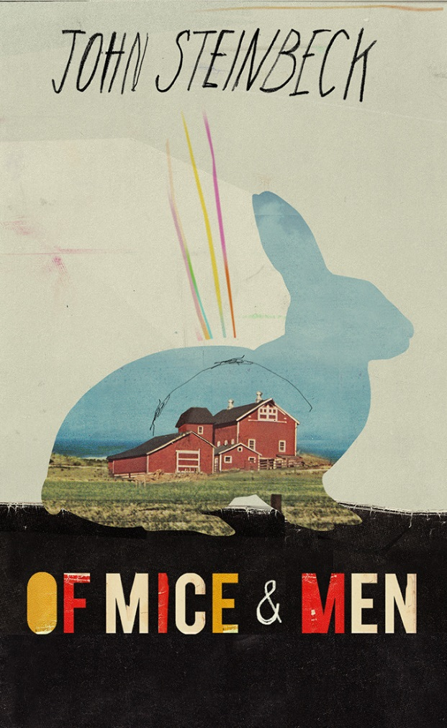
Of Mice and Men (20%)
Unit 1: Exploring Modern Texts (40%) One exam paper of 1.5 hrs:

45 mins on 2 short essays worth 30 marks. You will be given an extract to analyse, then you choose your own.

Useful Revision Websites:
http://www.dailymotion.com/video/xv2skv_gcse-english-literature-of-mice-and-men-a-grade-planning-for-section-b-aqa-modern-texts_school
http://www.dailymotion.com/video/xv2sis_gcse-english-literature-aqa-modern-texts-mark-scheme-analysis_school
http://www.icknield.beds.sch.uk/documents/study/miceandmen/ofmiceandmenrevisionguide.pdf
http://www.sparknotes.com/lit/micemen/

Aiming Higher in Of Mice and Men
This section of the GCSE Literature examination requires you to:
- respond to texts critically, sensitively and in detail, selecting appropriate ways to convey their response, using textual evidence as appropriate;
- explore how language, structure and forms contribute to the meanings of texts, considering different approaches to texts and alternative interpretations;
- make detailed and appropriate links to context of the text.

Check your target grade against the criteria on the Learning Triangle below so you know exactly what you need to do to achieve. Ask your teacher if you are unsure.

A* essay (1) - marked
Question
Read the extract below taken from Of Mice and Men, Chapter 5. How much sympathy do you feel for Candy at this point?
George turned and went quickly out of the barn. Old Candy watched him go. He looked helplessly back at Curley’s wife, and gradually his sorrow and his anger grew into words. ‘You God damn tramp,’ he said viciously. ‘You done it, di’n’t you? I s’pose you’re glad. Everbody knowed you’d mess things up. You wasn’t no good. You ain’t no good now, you lousy tart.’ He sniveled, and his voice shook. ‘I could of hoed in the garden and washed dishes for them guys.’ He paused and then went on in a singsong. And he repeated the old words: ‘If they was a circus or a baseball game…we would of went to her…jus’ said ‘ta hell with work an’ went to her.
Essay
I feel a certain degree of sympathy for Candy, who had been living a hopeless existence, disabled and demoted to swamper with little chance of achieving very much, saving little bits of money but with no purpose until Lennie and George’s arrival. With them came the dream. Candy finally had something to look forward to and something worthwhile that he could invest in. Instead of being lonely and isolated, separated from the other workers because of his inability to equal them with the manual tasks they carried out, he found allies in Lennie and George. Their friendship eventually extended to encompass him. He was part of something, united by the dream, had some purpose, ‘I could of hoed in the garden and washed dishes for them guys.’
Clear introduction, well structured. Responds directly to question. Independent discovery and interpretation of significant details.
I sympathise with Candy in his realisation that the dream would not be fulfilled. I think it is worse to have had hopes dashed than to have had no hopes in the first place. He is now conscious of what he stands to lose. Steinbeck describes him as ‘Old Candy’, conjuring up images of weakness, frailty and dependence. ‘He sniveled and his voice shook.’ The implication here is that Candy has lost his self-control. He is becoming consumed by ‘his anger and his sorrow.’ Lennie was an integral part of the dream and George had no interest in pursuing it without him. It is interesting that Candy does not express his bitterness towards Lennie, but instead towards Curley’s wife.
Close textual evaluation.
Independent interpretation of significant details.

Steinbeck uses Curley’s wife to reveal a common attitude towards women and expose the hypocrisy that allows Curley to visit whorehouses, but denies his wife the opportunity to just talk to other men. Candy says to her, ‘You gotta husban’. You got no call foolin’ aroun’ with other guys, causin’ trouble.’ This type of accusation suggests that Candy considers himself on the moral highground and Curley’s wife’s superior. This scrabble to avoid occupying the lowest rung in the social ladder evokes some pity.
Insight into writer’s methods and purposes. Convincing interpretation.

Steinbeck uses a number of characters to represent groups of people and Curley’s wife is Steinbeck’s vehicle to explore men’s oppression of women and the way that they are treated as inferior. Curley’s wife is the only developed female character. The others, such as the women in the whorehouse, provide a service for men and are presented through their function rather than as people; their identities are irrelevant. Even with Curley’s wife Steinbeck has deliberately maintained a degree of anonymity, never revealing her name.
Consistent insight.
Subtle response to implications of the question.

When having a stake in the dream had first become a possibility for Candy, Curley’s wife had arrived soon after, cruelly portraying Candy, Lennie and Crooks as they might appear to others, ‘a bunch of bindle stiffs – a nigger an’ a dum-dum an’a lousy ol’ sheep’. Her description of him as a ‘lousy ol’ sheep’ presented Candy as useless and at this point in the novel I felt some sympathy for Candy along with the other two characters under attack.
Evaluative personal response.

Candy went on to boast that getting them sacked would not matter as they had their own farm. She didn’t believe him. Then later, in an ironic twist, Curley’s wife’s death ensures that they do not, in fact, get their own place.
Strong awareness

Candy is in a vulnerable position on the ranch. Because of having only one arm it was difficult for Candy to find work and he was particularly dispensable. After asserting himself and the others and declaring their independence from Curley and his family, I sympathise with Candy finding himself again reliant on Curley’s family’s charity as a result of Curley’s wife’ death
Perceptive

However, I find it difficult to wholly sympathise with a character that reveals himself to be such a misogynist. In the extract Candy calls her a ‘tramp’ and a ‘tart’, derogatory terms that are only applicable to women. Candy’s words are direct and vicious, he repeatedly uses the second person pronoun ‘you’ making his tone accusing and pinpointing his anger specifically on Curley’s wife. The misogyny extends beyond name-calling and perhaps this is representative of the men’s general sentiment towards her.
Close textual analysis.
Independent discovery.
Furthermore, Candy blames Curley’s wife for wrecking his dream, expressing his hatred for her (‘… he said viciously. “You done it, di’n’t you?” ’), putting words into the dead body’s mouth, like forcing a false confession. I don’t believe that Curley’s wife can be held responsible for her own death and feel that Steinbeck always presented her as the underdog at the bottom of the hierarchy, not having her own name and simply referring to her as one of Curley’s possessions. I feel that it was easier for Candy to blame her for the loss of the dream. He had colluded with George to defer revealing her death and being Lennie’s best friend it had made it difficult for Candy to focus his blame on to Lennie. Instead, an ungenerous spirit is revealed as Candy directs his anger and misery at the dead body in front of him. He is unswervingly unforgiving of Curley’s wife: ‘ “You wasn’t no good. You ain’t no good now.” ’
Subtle and forceful response to implications of the question
Insightful discovery
‘He looked helplessly back at Curley’s wife, and gradually his sorrow and his anger grew into words.’ Candy’s mourning for the loss of his dream and the chance of a happier life is pitiful, but his inability to see beyond his own selfish desires and the weakness in his character that prevents him from expressing anything but violent hatred towards Curley’s wife make it difficult to feel much more than pity.
Overall assessment
An articulate and well informed essay. It shows consistent insight and good analytical and evaluative skills. The forceful response to the question remains relevant and demonstrates independent discovery and interpretation throughout.

Note that in order to achieve an A* it is vital that you discuss Steinbeck’s use of language and his intentions. Go back through the essay and identify the places where these aspects are explored, annotate with L and S to show each.

A* essay (2)
‘Nobody never gets to heaven, and nobody never gets no land. It’s just in their head.’ To what extent is Of Mice and Men a novel about unfulfilled dreams?

There are a number of characters in Of Mice and Men who have dreams of a better life. These characters include George, Lennie and Candy, who dream of a farm of their own, and Curley’s wife, who dreams of becoming a glamorous Hollywood actress. In this essay I will discuss their dreams and the effects on the novel’s characters when their dreams are unfulfilled.
The central characters in Of Mice and Men are George and Lennie. Their dream is introduced to the reader in the first chapter,

‘OK. Someday we’re gonna get the jack together and we’re gonna have a little house and a couple of acres an’ a cow and some pigs and –
‘An’ live off the fatta the lan’,’ Lennie shouted. ‘An’ have rabbits.’

George and Lennie’s dream is to leave behind their lives as travelling workers and have a place of their own where they can settle down. For Lennie the dream of living on their own farm is closely connected to looking after rabbits. Perhaps this is because the only way that Lennie can actually relate to the dream is through the idea of something practical and touchable which relates to his tactile qualities. Clearly, the material aspect of owning his own land means very little to Lennie. At the start of the novel we learn that Lennie likes to pet soft things, like mice and rabbits. It is this trait that eventually leads to Lennie’s downfall when he tries to smooth Curley’s wife’s soft hair.
However, for George the dream of the farm has other benefits. Firstly, George can see the practical, economic advantage of owning their own place.

‘If I was bright, if I was even a little bit smart, I’d have my own little place, an’ I’d be bringin’ in my own crops, ‘stead of doin’ all the work and not getting what comes up outta the ground.’

Yet it is not just the practical benefits of owning a farm that attract George to this dream. We learn that George has no family – ‘I ain’t got no people’, and it seems as though the dream of a farm also represents the notion of ‘home’ to George.

‘An’ we’d keep a few pigeons to go flyin’ around the win’mill like they done when I was a kid’…’We’d jus’ live there. We’d belong there.’

So, for George, the dream of a farm offers a psychological antidote to his rootless, travelling life and gives him a sense of belonging.
Another attraction of the farm dream is that it gives George the promise of some sense of control and autonomy in his life. In his conversation with Candy about owning a farm, George says:

‘S’pose they was a carnival or a circus come to town, or a ball game, or any damn thing.’ Old Candy nodded in appreciation of the idea. ‘We’d just go to her,’ George said. ‘We wouldn’t ask nobody if we could. Jus’ say ‘We’ll go to her’, an’ we would’.

This shows how powerless George feels in his life and how much power employers exercised over their workers at that time. Another example of George and Lennie’s powerlessness is shown after Lennie’s fight with Curley, the boss’s son; when George’s immediate concern is that they will be ‘canned’ or dismissed. However, in this situation, they retain their jobs because Slim steps in and persuades Curley to say he got his hand caught in a machine.
In Chapter 2 when George and Lennie discuss their dream they are overheard by Candy, the old swamper. Candy is immediately swept up with the idea of owning their own farm and offers his savings to them to make the dream come true. At this point in the novel it seems as if the dream could actually become a reality.

They fell into silence. They looked at one another, amazed. This thing they had never really believed in was coming true. George said reverently, ‘Jesus Christ! I bet we could swing her.’ His eyes were full of wonder.

What is interesting is that at this point in the novel the dream of the farm actually moves from being a pipe dream which will probably never happen, to an achievable goal which is actually within their grasp. It is Candy’s involvement that makes this change take place.
Although Candy shares George’s reasons for wanting a farm, there is also an extra dimension for Candy wanting to live on their own place. We get the sense that Candy feels redundant, useless and vulnerable because he is old and has lost his hand. Candy feels uneasy about his future: ‘ “They’ll can me purty soon. Jus’ as soon as I can’t swamp out no bunk houses they’ll put me on the county.”’ So for Candy the dream of the farm means independence – ‘nobody could can us’, because in his present situation he is entirely dependent on the boss’s tolerance and charity. In the novel, this is partially demonstrated by Carlson shooting Candy’s dog earlier that evening. In an echo of Candy’s own situation of the ranch, Carlson, without much pity or concern, shoots Candy’s dog because he is old and it is inconvenient to keep him because of the smell. It is not hard to imagine that Candy feels there is a parallel between his own situation and his dog’s.
Candy’s attachment to the dream of their own farm is demonstrated in Chapter 5 when he realises that all hopes of the dream have come crashing down when he discovers Curley’s wife’s dead body:

‘You God damn tramp’, he said viciously. ‘You done it, di’n’t you? I s’pose you’re glad. Ever’body knowed you’d mess things up…’If they was a circus or a baseball game … we would of went to her … Never ast nobody’s say so.’

Candy’s reaction reveals how powerful and important the dream was to him and how bitter and angry he feels because he realises that their dream will now not be fulfilled.
In the novel, Curley’s wife also experiences an unfulfilled dream. In Chapter 5 she tells Lennie that she dreamed of becoming a Hollywood actress. However, we learn that her dream did not come true because, firstly, her mother wouldn’t let her join a travelling show and later, when she met a guy in show business who said he’d write to her, she didn’t receive the letter and became convinced that her mother had stolen it. Even though she blames her mother, we get the feeling that these dreams would not have come true anyway. When she talks about meeting the guy in show business she demonstrates an innocent, teenage attitude and her language reveals that it is likely that she was being duped by the guy she met:

‘Nother time I met a guy, an’ he was in pitchers. Went out to the Riverside Dance Palace with him. He says he was gonna put me in the movies. Says I was a natural. Soon’s he got back to Hollywood he was gonna write to me about it’…’I never got that letter’.

As the conversation progresses Curley’s wife explains how she married Curley in a disappointed over-reaction to not being able to fulfil her dream.

‘I always thought my ol’ lady stole it. Well, I wasn’t gonna stay no place where I couldn’t get nowhere or make something of myself, an’ where they stole your letters. I ast her if she stole it, too, an’ she says no. So I married Curley. Met him out to the Riverside Dance Palace that same night.’
This demonstrates Curley’s wife’s frustration and her unconsidered approach to life. Steinbeck has created Curley’s wife, like many other characters in the novel, as a character with an underlying pathos. She admits to Lennie that her marriage to Curley is an unhappy one, ‘I don’t like Curley. He ain’t a nice fella’. Unfortunately the sadness of not being able to fulfil her dream leads her to marry Curley, which in turn leads to the tragedy of her early death. It is interesting that, unlike George, Lennie and Candy, Curley’s wife’s dream is based in the past. Yet even though it is over and done with, she still clings to it as an important part of her identity and she still needs to talk about it, even if her only audience is Lennie. By having Curley’s wife discuss her broken dreams, Steinbeck creates another side to her character, a side we can feel more sympathy with and a contrast to her harsh or vampish sides.
Of all the people on the ranch who might need a dream to keep them going, Crooks seems the one who might need it the most. When he first learns of George, Lennie and Candy’s plan to buy their own farm he is sceptical at first. Then when he realises that it might happen, he too is swept along by the idea:

‘If you.. guys would want a hand to work for nothing – just his keep, why I’d come an’ lend a hand. I ain’t so crippled I can’t work like a son-of-a-bitch if I want to.’

Then, with the arrival of Curley’s wife and the ensuing argument, Crooks is reminded of his ‘position’ as a negro in that society at that time: ‘“Well, you keep your place then, Nigger. I could get you strung up on a tree so easy it ain’t even funny.” After this interaction Crooks withdraws into himself: ‘Crooks had reduced himself to nothing. There was no personality, no ego – nothing to arouse either like or dislike. He said, “yes, ma’am”, and his voice was toneless.’
Crooks is presented as such a powerless character because he was a black man in a prejudiced society, with very limited rights. We find that he has been so affected by the way he is treated by others that he finds it hard to even dream of a better way of life. After Curley’s wife has left, Crooks realises that he can’t be part of the dream, ‘You guys comin’ in an’ settin’ made me forget. What she says is true.’ At the end of the chapter, Crooks withdraws his request to join their future dream farm: ‘“Member what I said about hoein’ and doin’ odd jobs?… Well, jus’ forget it.”’ By doing this, Crooks demonstrates a cautious attitude towards the dream, keeping it at arm’s length, perhaps because past experiences have taught him not to step out of his ‘place’ and he doesn’t want to be hurt by raising his expectations only to see them dashed.
In Crooks, Steinbeck represents what life would have been like for black workers in California at that time. In an already tough set of circumstances, Crooks has a double disadvantage because he is black and alone. In this sense, Crooks is possibly the saddest character that Steinbeck created in the novel because he can barely even dare to dream of a better life.
At the end of the novel, when George shoots Lennie, George asks Lennie to kneel down, look out across the valley and remember their dream. On one level it seems that George wants Lennie to at least be happy in the final moments of his life. Yet on another level, it seems as if George realises that by shooting Lennie, he is also symbolically killing the dream too. Although there is no practical reason why George and Candy still couldn’t get the farm on their own, there is a sense that the spell has been broken and things will never be the same again.
From the start of the novel, when George and Lennie first start to talk about the dream of their own farm we learn that they often talk about this subject:

Lennie pleaded, ‘Come on, George. Tell me. Please, George. Like you done before.’
…‘You got it by heart. You can do it yourself.’

We learn that Lennie delights in hearing about the farm over and over, so that it seems like a well loved story that a parent would tell a child. The fact that both men revel in repeating the ‘story’ makes it seem like a dream and they are almost wishing it to come true. The dream does truly seem like a dream when you consider the cosy, almost fairytale language that George uses to describe their farm:
‘Sure, we’d have a little house an’ a room to ourself. Little fat iron stove, an’ in the winter we’d keep a fire goin’.’

The repeated use of the word ‘little’ creates a very story-like, unreal atmosphere. George also uses the indefinite article to describe the features of the farm (‘a’ as opposed to ‘the’) which again takes away any ‘concrete’ qualities and makes it seem nebulous. Later we learn that, ‘George sat entranced with his own picture’, and we realise that George has created an unreal picture of the farm which we suspect will not come into being because the story-like descriptions make it seem so remote and unobtainable.
As the novel progresses the reader picks up other clues which hint that the dream of the farm will not be fulfilled. When we first learn about what happened in Weed between Lennie and the girl in the red dress, it becomes apparent that Lennie has the potential to get into trouble in a way that George can’t always control. Steinbeck also drops hints about Lennie’s impending doom. When George and Lennie first meet Curley’s wife, they both realise that she could mean trouble:

‘You keep away from her, ’cause she’s a rattrap if I ever seen one.’
‘Le’s go, George. Le’s get outta here. It’s mean here.’

Through the novel we also learn that Lennie likes to pet soft things, which leads to an accusation of rape, the death of a mouse, then the death of a puppy and we suspect that it could be building up to a greater tragedy. Yet perhaps the biggest clue that George and Lennie’s dream will not be fulfilled is in Candy and Lennie’s conversation with Crooks:

‘I seen hundreds of men come by on the road an’ on the ranches, with their bindles on their back an’ that same damn thing in their head. Hundreds of them. They come, an’ they quit an’ go on; an’ every damn one of ‘em’s got a little piece of land in his head. An’ never a God damn one of ‘em ever gets it.’

From Crook’s words it seems that George and Lennie’s is a common dream for migrant workers at that time and we suspect that they, like many others, will not get their piece of land.
In this novel Steinbeck has used the plight of migrant workers travelling around California in the Depression as a vehicle to explore the concept of having a ‘dream’. This ties in with the idea of the ‘American Dream’ – the notion that if you work hard enough and try hard enough, then anybody can succeed and get what they want. In Of Mice and Men not only does Steinbeck comment on the conditions in 1930s America but he also uses a range of almost representative characters to explore and make observations about how different people formulate dreams and react to the loss of them.
In the end, Steinbeck’s message about dreams is set out in the title of the novel. Taken from the Burns poem, the line ‘of mice and men’ refers to the plight of a mouse who worked hard to build a nest, only to have it destroyed by a farmer. The message in the poem and the message in the novel are the same and it is a message that is very much about broken and unfulfilled dreams. No matter what we plan or how hard we work, some things are inevitable and fate has a plan of its own which we can’t avoid.

Activity 10: Selecting the best points
This essay is far too long to have been written in the examination. Look back at the essay, which paragraphs would you remove to ensure the essay still attained an A* grade but could have been written in 45 minutes?

Unit 1: Exploring Modern Texts (40%) One exam paper of 1.5 hrs:

Sunlight on the Grass Short Stories (20%)

45 mins on 2 short essays worth 30 marks. You will be given one story to focus on, then you choose your own.

Useful Revision Websites:
http://milneenglishaccident.blogspot.co.uk/2013/03/revision-videos-unit-1-literature.html
http://www.youtube.com/watch?v=wkIUTSuz8tc&index=2&list=PLqGFsWf-P-cB7OFSTfeSXgGtK32L8v7kH
For A* analysis and revision for all short stories:
http://www.youtube.com/playlist?list=PLqGFsWf-P-cB7OFSTfeSXgGtK32L8v7kH

Sunlight on the Grass:

Unit 4: Approaching Shakespeare and the English Literary Heritage (35%) One exam paper of 1.5 hrs

Animal Farm (15%)
40 mins on one extended essay worth 24 marks.

Useful Revision Websites:
http://www.gradesaver.com/animal-farm/
http://www.youtube.com/watch?v=7tve0bv34Vc
http://www.shmoop.com/animal-farm/

ANIMAL FARM - Much More Than A 'FAIRY STORY'

You probably realised very quickly when you began to read Animal Farm that it is much more than the 'fairy story' which Orwell used as a sub-title for his book.

A more accurate description than 'fairy story' would be 'a fable' which is a story which uses animal characters to tell us something about human nature and institutions.

In a fable the characters are often representative types, not fully rounded characters such as we would expect to find in a novel: the fox will always be crafty, the sheep will always be stupid, the pigs will always be lazy and selfish.

Orwell does present his characters as types with easily-distinguished qualities - the pigs are exploiters, the horses are labourers, the sheep are easily led, the dogs are trained to be vicious - but at the same time he gives the most important characters their own particular personalities which makes them much more memorable and moving.

Allegory

Animal Farm is an allegory. That is, the characters and events in the book all stand for something else. In fact, we can clearly see three levels of meaning in the novel:

Literal A kind of fairy story or fable about animals

Historical A criticism of the Russian Revolution and its aftermath.

General A general criticism of how political hopes and ideals can be betrayed.

Satire

To 'satirise' something is to ridicule it by mocking or making fun of it.

Orwell uses satire to criticise what he saw as the failure of Communism in Russia. The satire in Animal Farm is very obvious because real historical figures such as Stalin are portrayed as animals (Napoleon), most of them in an uncomplimentary way.

For many years Animal Farm was banned in Russia because the authorities there were so sensitive about its critical content.

However, you do not have to know anything about the connection between the novel and Stalin's Russia to appreciate and enjoy Animal Farm. The novel does a wonderful job in satirising any group of people who try to take over a country or an organisation and begin to run it for themselves without taking into account the rights of other people who belong to that country or institution.
Language

As we can tell from the novel, Orwell was against the use of fancy, complicated, high-flown language which is used to conceal the truth rather than reveal it. It is worth noting that Orwell is critical of the wordy language and jargon used by Snowball and Squealer in the novel.

The presentation of the story as a kind of fable demands simple, direct language, but Orwell made it clear in his other works that be believed writing should be kept as simple and natural as possible. Much younger readers can enjoy Animal Farm as a fable without having to understand and appreciate its deeper levels of meaning.

Here are Orwell's own rules for writing:

1 Never use a long word where a short one will do

2 If it is possible to cut a word out, always cut it out

3 Never use a foreign phrase, a scientific word or
a jargon word if you can think of an everyday
English equivalent

4 Never use a metaphor, simile or other figure of speech
which you are used to seeing in print

5 Never use the passive where you can use the active

6 Break any of these rules sooner than say anything outright barbarous

Irony

Irony is hard to define precisely and there are different types of irony. Generally, irony exists when the readers are aware of something which the characters are not aware and which changes the reader's perspective on the situation.

Perhaps the greatest irony in Animal Farm is at the end when the pigs become so like their human masters that the other animals cannot tell the difference. The pigs themselves are unaware of what has happened to them, and the irony is that they have become what they hated and feared most at the start of the novel.

When something is the story seems to be the case and we, because we have been given a privileged view of the events, know it is not the case (and very often the precise opposite of the case), irony is at work.

Irony can be comic; irony can be savage.

For example, there is strong irony when Boxer asks Napoleon for permission to release the dog which has attacked him (Chapter 7). We readers realise what Boxer does not - that it was Napoleon who had ordered the dogs to attack him in the first place.

There are many examples of irony in Animal Farm. Take a closer look at these and discuss what is so ironical about the incidents:

Ch. 2 The pigs solve the problem of the milk.
Ch. 8 Napoleon discovers the banknotes are forged.
Ch. 9 The pigs acquire another crate of whisky.
Ch. 9 Boxer is sent to his death.

Humour

In many ways Animal Farm is a very grim novel giving a very dark and pessimistic view of human nature, but there is also a great deal of humour in the tale. For it is part of the human condition that men (and women) are often able to find humour in the grimmest of situations.

Some of the humour is created by the idea of animals thinking and acting like humans, but that is humour at a low level.

The real humour is when the reader of Animal Farm discovers so much that it comic and amusing about human beings themselves, especially when the reader discovers something of himself in the characters of the novel. We all have a Boxer within us, a Snowball, a Squealer, and Mollie, too.

Here are some comic moments. What makes them humorous?
Can you add your own favourite comic moments to the list?

- the cat persuading the birds to join a committee
- the vanity of Mollie
- Snowball's 'proof' that a wing is a leg
- the way the old ram (in Ch. 7) is said to have been
killed
- the 'Comrade Napoleon is dying' story (Ch. 8)

GEORGE ORWELL 1903-1950
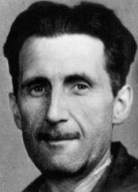
Who was George Orwell?

The author of Animal Farm was born in 1903 in India when it was part of the British Empire.

His real name was Eric Blair and he came from an upper middle-class background. His father and both is grandfathers made their livings in Burma and India which were under British rule until 1947.

What were his schooldays like?

Orwell's early school days were spent in a private boarding school, called St Cyprians, which he hated. He hated the snobbery, the dictatorial regime, the extremely Spartan conditions, the terrible food and the frequent bullying.

There can be little doubt that Orwell based some of his descriptions in Animal Farm on his miserable life at St. Cyprians where he stayed until he was nearly fourteen. Perhaps it was here that he first learned to hate injustice and unchecked power.

After St. Cyprians, Orwell won a scholarship to Eton, one of England's most famous and exclusive public schools. He enjoyed the relaxed atmosphere which gave him more room to 'develop his individuality'.

How did Orwell learn about imperialism?

When he left Eton, Orwell followed the family tradition by joining the Indian Imperial Police. He served in Burma where he observed the workings of imperialism at close quarters. He knew it was an unjust system and gradually came to despise the way in which it exploited and oppressed the poor and the hungry.

How did Orwell become a writer?

After working in Burma for five years, Orwell resigned from the Police Force and returned to England to try his hand at becoming a writer.

To gather material for a book he decided to take to the road and learn about people who had fallen on hard times: tramps, beggars, prostitutes and criminals. He explored the worst areas of London and Paris doing casual work and sleeping rough. He was determined to find out at first hand what it was like to live at the bottom of society.

In 1933, at the age of thirty, Orwell published his first book, called Down and Out in Paris and London. It was the first time he used the name of George Orwell. He probably took the surname from the River Orwell which ran close to his parents' home in Suffolk.

How did Orwell become a socialist?

A socialist believes that all people in any society are of equal worth and value because we are all human beings. Therefore, a socialist believes that everybody in any society should be given equal opportunities and that society has a duty and a responsibility to make sure that all its members have reasonable standards of care and help throughout their lives. A socialist believes that every member of society is ultimately responsible for every other member of society.

George Orwell became a socialist.

In 1936 Orwell was asked by his publisher to write a book about the poor and unemployed in the north of England, especially the mining community. It was a time of mass unemployment and great hardship for working people.

Orwell was very moved by what he saw and his anger at the injustices he witnessed helped to make him into a committed socialist. The book in which he described his experiences is called The Road to Wigan Pier.

After several years of living rough Orwell took a job as a teacher in a private school in order to earn some money. He worked hard at his job and also managed to write two more novels. Around this time Orwell went to live in the country with Eileen O'Shaughnessy who he had married a year earlier.

Orwell goes to war

Orwell's life was dramatically changed by the Spanish Civil War which broke out in 1936. He and Eileen went out to join the Republican forces in their struggle against the fascists led by General Franco. Writers, intellectuals and trade unionists from all over Europe, many of them from Britain, flocked to join the International Brigade.

The Communist Party, backed Stalin, was also fighting against Franco's fascists. At first they worked together with the International Brigade but gradually the Communists turned against them and began persecuting Spanish socialists because Stalin did not want to see them really changing society and winning real freedom.

Orwell saw that the Communism preached by Stalin was really another form of fascism, another form of rule over the very many by the very few, just another form of totalitarianism.

Orwell writes Animal Farm

Orwell was badly wounded in the neck while he was fighting in Spain. When he returned to England, he began to plan some kind of attack on al forms of totalitarianism. Animal Farm was the result.

In 1945, at the end of the Second World War, he published Animal Farm which became an enormous success.

Shortly afterwards his wife died and Orwell brought up their adopted son on his own. In 1948 he published his most famous book, 1984, in which he imagined what Britain would be like under a totalitarian dictatorship.

George Orwell remained a firm socialist until his death in 1950 at the age of 47.

The origins of Animal Farm

George Orwell was once asked where he had got the idea for Animal Farm. He replied:

“...the actual details of the story did not come to me for some time until one day (I was then living in a small village) I saw a little boy, perhaps ten years old, driving a huge cart horse along a narrow path, whipping it whenever it tried to turn. It struck me that if only such animals became aware of their strength we should have no power over them, and that men exploit animals in much the same way as the rich exploit the proletariat.”

ANIMAL FARM - Examination Practice

A Mr. Whymper, a solicitor living in Willingdon, had agreed to act as intermediary between Animal Farm and the outside world, and would visit the farm every Monday morning to receive his instructions. Napoleon ended his speech with the usual cry of 'Long Live Animal Farm!', and after singing of 'Beasts of England' the animals were dismissed.
Afterwards Squealer made a round of the farm and set the animals' minds at rest. He assured them that the resolution against engaging in trade and using money had never been passed, or even suggested. It was pure imagination, probably traceable in the beginning to lies circulated by Snowball. A few animals still felt faintly doubtful, but Squealer asked them shrewdly, 'Are you certain that this is not something that you have dreamed, comrades? Have you any record of such a resolution? Is it written down anywhere?' And since it was certainly true that nothing of the kind existed in writing, the animals were satisfied that they had been mistaken.
Every Monday Mr. Whymper visited the farm as had been arranged. He was a sly-looking little man with side whiskers, a solicitor in a very small way of business, but sharp enough to have realised earlier than anyone else that Animal Farm would need a broker and that the commissions would be worth having.
The animals watched his coming and going with a kind of dread, and avoided him as much as possible. Nevertheless, the sight of Napoleon, on all fours, delivering orders to Whymper, who stood on two legs, roused their pride and partly reconciled them to the new arrangements.
Their relations with the human race were now not quite the same as they had been before. The human beings did not hate Animal Farm any less now that it was prospering, indeed they hated it more than ever. Every human being held it as an article of faith that the farm would go bankrupt sooner or later, and, above all, that the windmill would be a failure.
They would meet in the public-houses and prove to one another by means of diagrams that the windmill was bound to fall down, or that if it did stand up, then it would never work. And yet, against their will, they had developed a certain respect for the efficiency with which the animals were managing their own affairs. One symptom of this was that they had begun to call Animal Farm by its proper name and ceased to pretend that it was called the Manor Farm. They had also dropped their championship of Jones, who had given up hope of getting his farm back and gone to live in another part of the county.

Except through Whymper there was as yet no contact between Animal Farm and the outside world, but there were constant rumours that Napoleon was about to enter into a definite business agreement either with Mr. Pilkington of Foxwood or with Mr. Frederick of Pinchfield - but never, it was noticed, with both simultaneously.
It was about this time that the pigs suddenly moved into the farmhouse and took up their residence there. Again the animals seemed to remember that a resolution against this had been passed in the early days, and again Squealer was able to convince them that this was not the case. It was absolutely necessary, he said, that the pigs, who were the brains of the farm, should have a quiet place to work in. It was also more suited to the dignity of the Leader (for of late he had taken to speaking of Napoleon under the title of 'Leader') to live in a house than a mere sty.
Nevertheless some of the animals were disturbed when they heard that the pigs not only took their meals in the kitchen and used the drawing-room as a recreation room, but also slept in the beds.
Boxed passed it off as usual with 'Napoleon is always right!', but Clover, who thought she remembered a definite ruling against beds, went to the end of the barn and tried to puzzle out the Seven Commandments which were inscribed there. Finding herself unable to read more than individual letters, she fetched Muriel.
'Muriel,' she said, 'read me the Fourth Commandment. Does it not say something about never sleeping in a bed?'
With some difficulty Muriel spelt it out.
It says, “No animal shall sleep in a bed with sheets”' she announced finally.

QUESTIONS

1 In what ways had the attitude of humans changed towards Animal Farm since the Revolution? (10)

2 In what ways is Squealer's behaviour in this passage typical of his behaviour throughout the novel? (15)

3 'Animal Farm gives a very black picture of human nature.'
What evidence is there for and against this statement in the novel, and how far do you agree with it? (25)

